**Practical AI CA2**

**Gobest Cab Machine Learning**

**Project Report**

By

Class: DAAA/FT/2B/01

Team Members (Student ID):

Tan Wen Tao Bryan (2214449)

Ryan Yeo (2214452)

Zachary Leong Yao Jie (2201861)

Ethan Pang (2214241)

Submission Date: 8 February 2024

Word Count: 2490 words

(excluding headers & images)

Table of Contents

**1. INTRODUCTION3**

1.1 Project Objective3

**2. DATA UNDERSTANDING3**

2.1 Data Understanding3

**3. ADVANCED DATA PREPROCESSING4**

3.1 Data Processing4

3.2 Feature Engineering4

3.3 Feature Selection4

3.4 High-Dimensional Outliers Handling6

3.5 Handling Imbalanced Classes 7

**4. SCALABLE MACHINE LEARNING AND OPTIMIZATION8**

4.1 Model Development & Evaluation8

4.2 Model Optimization11

4.3 Final Model Export15

**5. MACHINE LEARNING EXPERIMENT MONITORING16**

5.1 ML Flow16

**6. MODEL DEPLOYMENT18**

6.1 Tkinter Graphical User Interface18

**7. CONCLUSION20**

**1 INTRODUCTION**

1.1 Project Objective

The primary objective of this project is to develop a comprehensive data science solution for GoBest Cab, a ride-hailing service company. The goal is to create an intuitive and portable machine learning software application that visualizes and analyzes cab data. The application could provide some insights into the drivers’ behaviour, and find out if they are dangerous or safe drivers.

Phase 2 of the project will include a few steps, advanced data preprocessing, building, optimizing and scaling the machine learning models on the huge dataset, tracking and monitoring the machine learning models on the dataset and deploying the machine learning models as a Graphical User Interface, which will serve as a user-friendly front-end to interact with the underlying machine learning model, promoting user-engagement.

**2 DATA UNDERSTANDING**

2.1 Data Understanding

Previously, we had preprocessed the data during Phase 1 of the project. As such, the data is made up of two hdf files, cab_driver_df and sensor_safety_df which is read in a chunksize of 10000.

The cab_driver_df is made up of 500 rows and 10 columns: driver_id, driver_name, date_of_birth, num_of_years_driving_exp, gender, car_brand, car_model_year, driver_rating, driver_age and car_age.

The sensor_safety_df is made up of 7126686 rows and 21 columns: sensor_id, booking_id, accuracy, bearing, acceleration_x, acceleration_y, acceleration_z, gyro_x, gyro_y, gyro_z, second, speed, driver_id, label, acceleration_magnitude, gyro_magnitude, pitch, roll, yaw, duration and distance.

One insight of the data that was found is that there are no missing values in the data.

**3 ADVANCED DATA PREPROCESSING**

3.1 Data Processing

To recap on the data preprocessing phase of the CA1, we had successfully imputed the missing values in the dataset by grouping by BookingID and KNNimputer. We have also removed extreme values in speed and seconds such as negative values and values that seem to be impossible to happen in the real world.

As part of data processing for Phase 2 of the project, the team will not be using cab_driver_df for a few reasons: 1) The information about the drivers is static which means more booking trips of the same driver will result in heavy bias that affects the model predictions. 2) The information in the dataframe (i.e. car_model, ratings, date_of_birth is not compatible with real-time data which is needed for the GoBest Cab machine learning application. Hence, we will only focus on using sensor_safety_df.

To start off, we will be dropping sensor_id as it is a column with only unique values.

3.2 Feature Engineering

To recap on the data preprocessing phase of the CA1, we had engineered a few features (i.e. acceleration magnitude, gyro magnitude, pitch, roll, yaw, duration & distance).

New features were engineered, rate of unsafe trips which the team obtained by grouping by bookingID and driver_id and calculating the mean of the labels to show the percentage of labels that are value of 1 which is the unsafe labels, and G-Force which is the acceleration due to gravity, calculating by acceleration divided by 9.81 due to gravity value.

Rate of Unsafe Trips G-Force

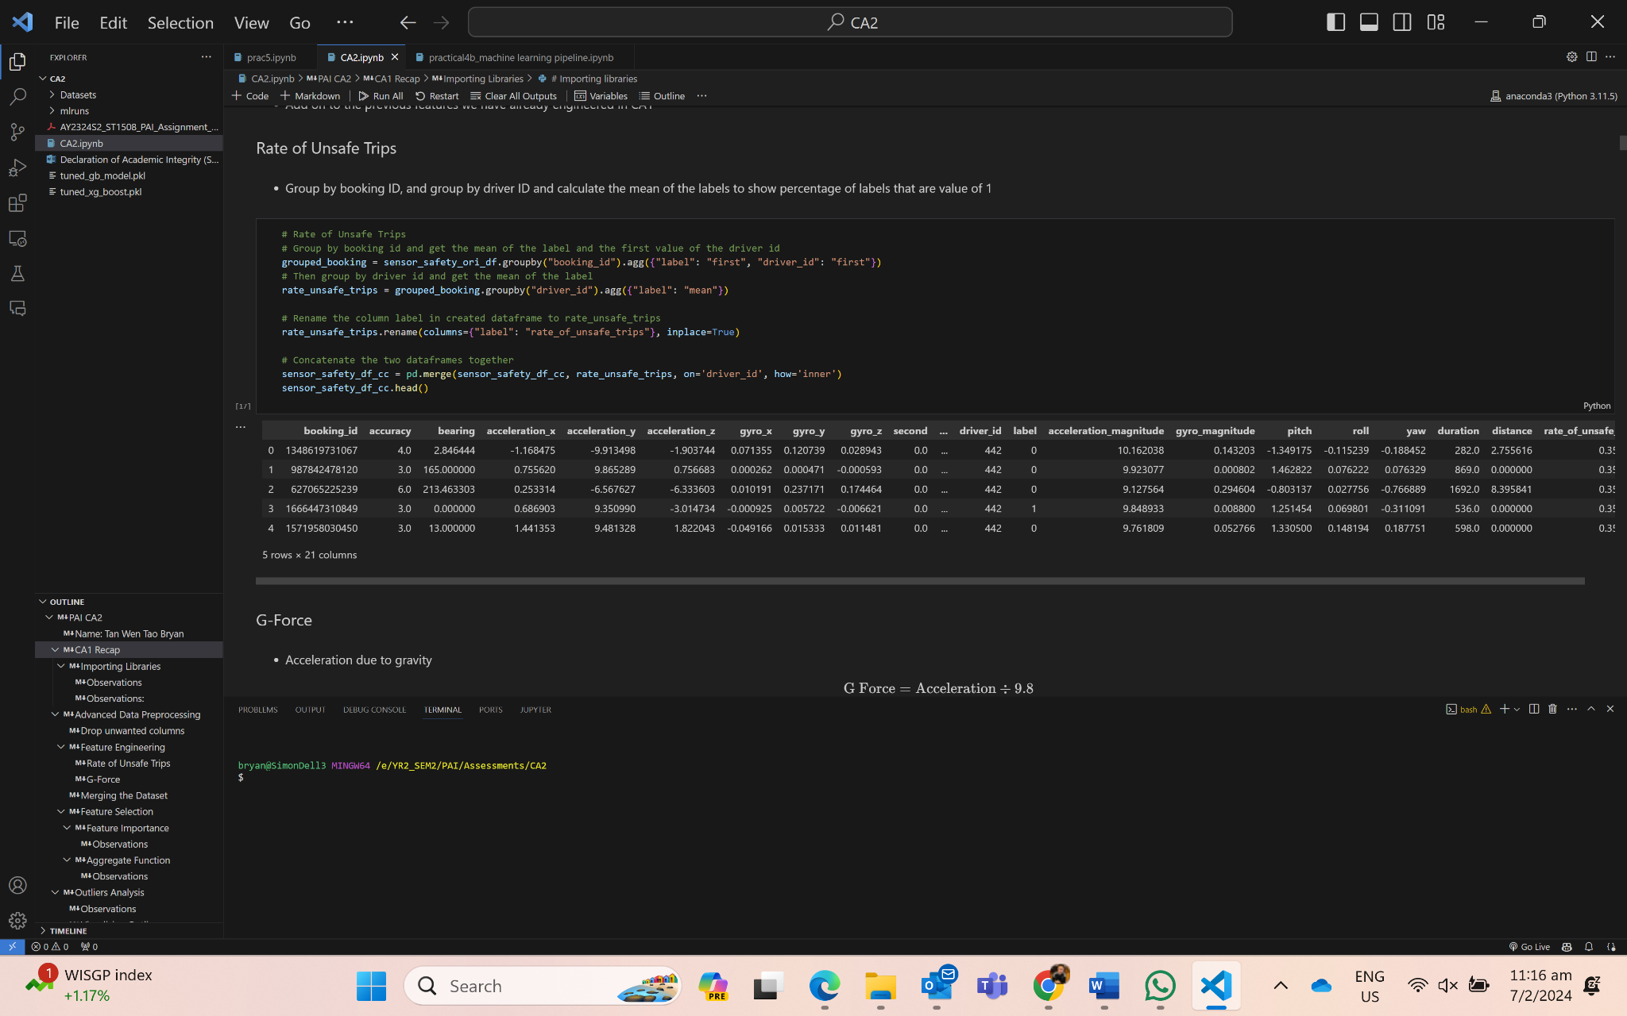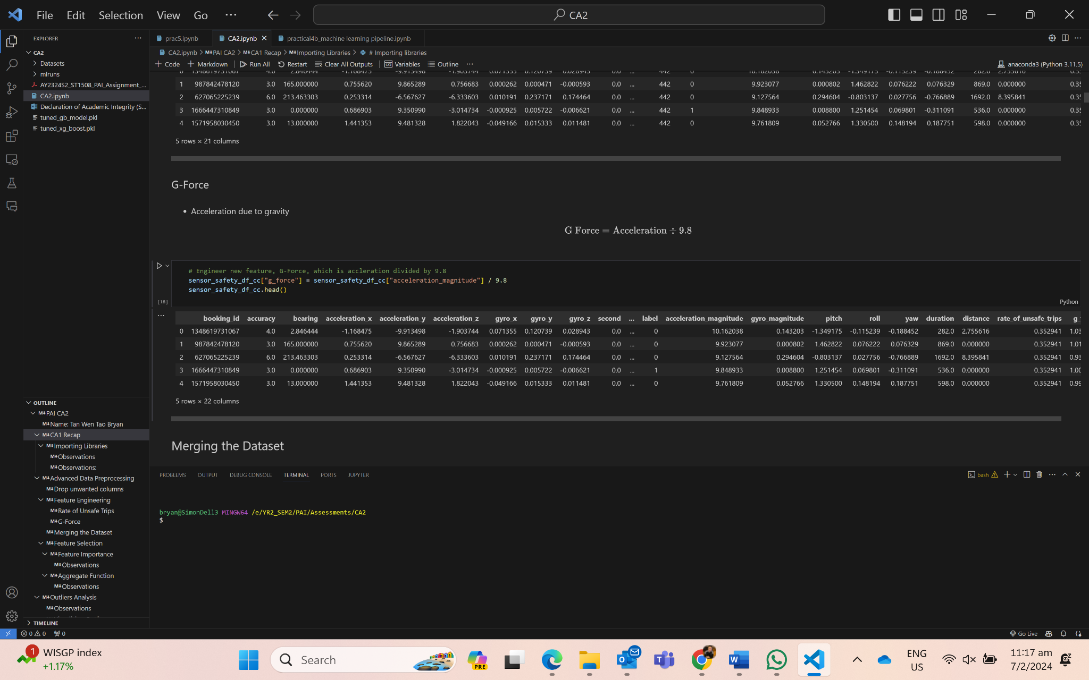

3.3 Feature Selection

There are a few ways to decide which features are meant to be kept and used for the training of the machine learning models. One way is by using DecisionTreeClassifier as the model to perform feature importance, the team will find out which features are important to the model by dropping the features with a coefficient of 0.04 or less.

DecisionTreeClassifier

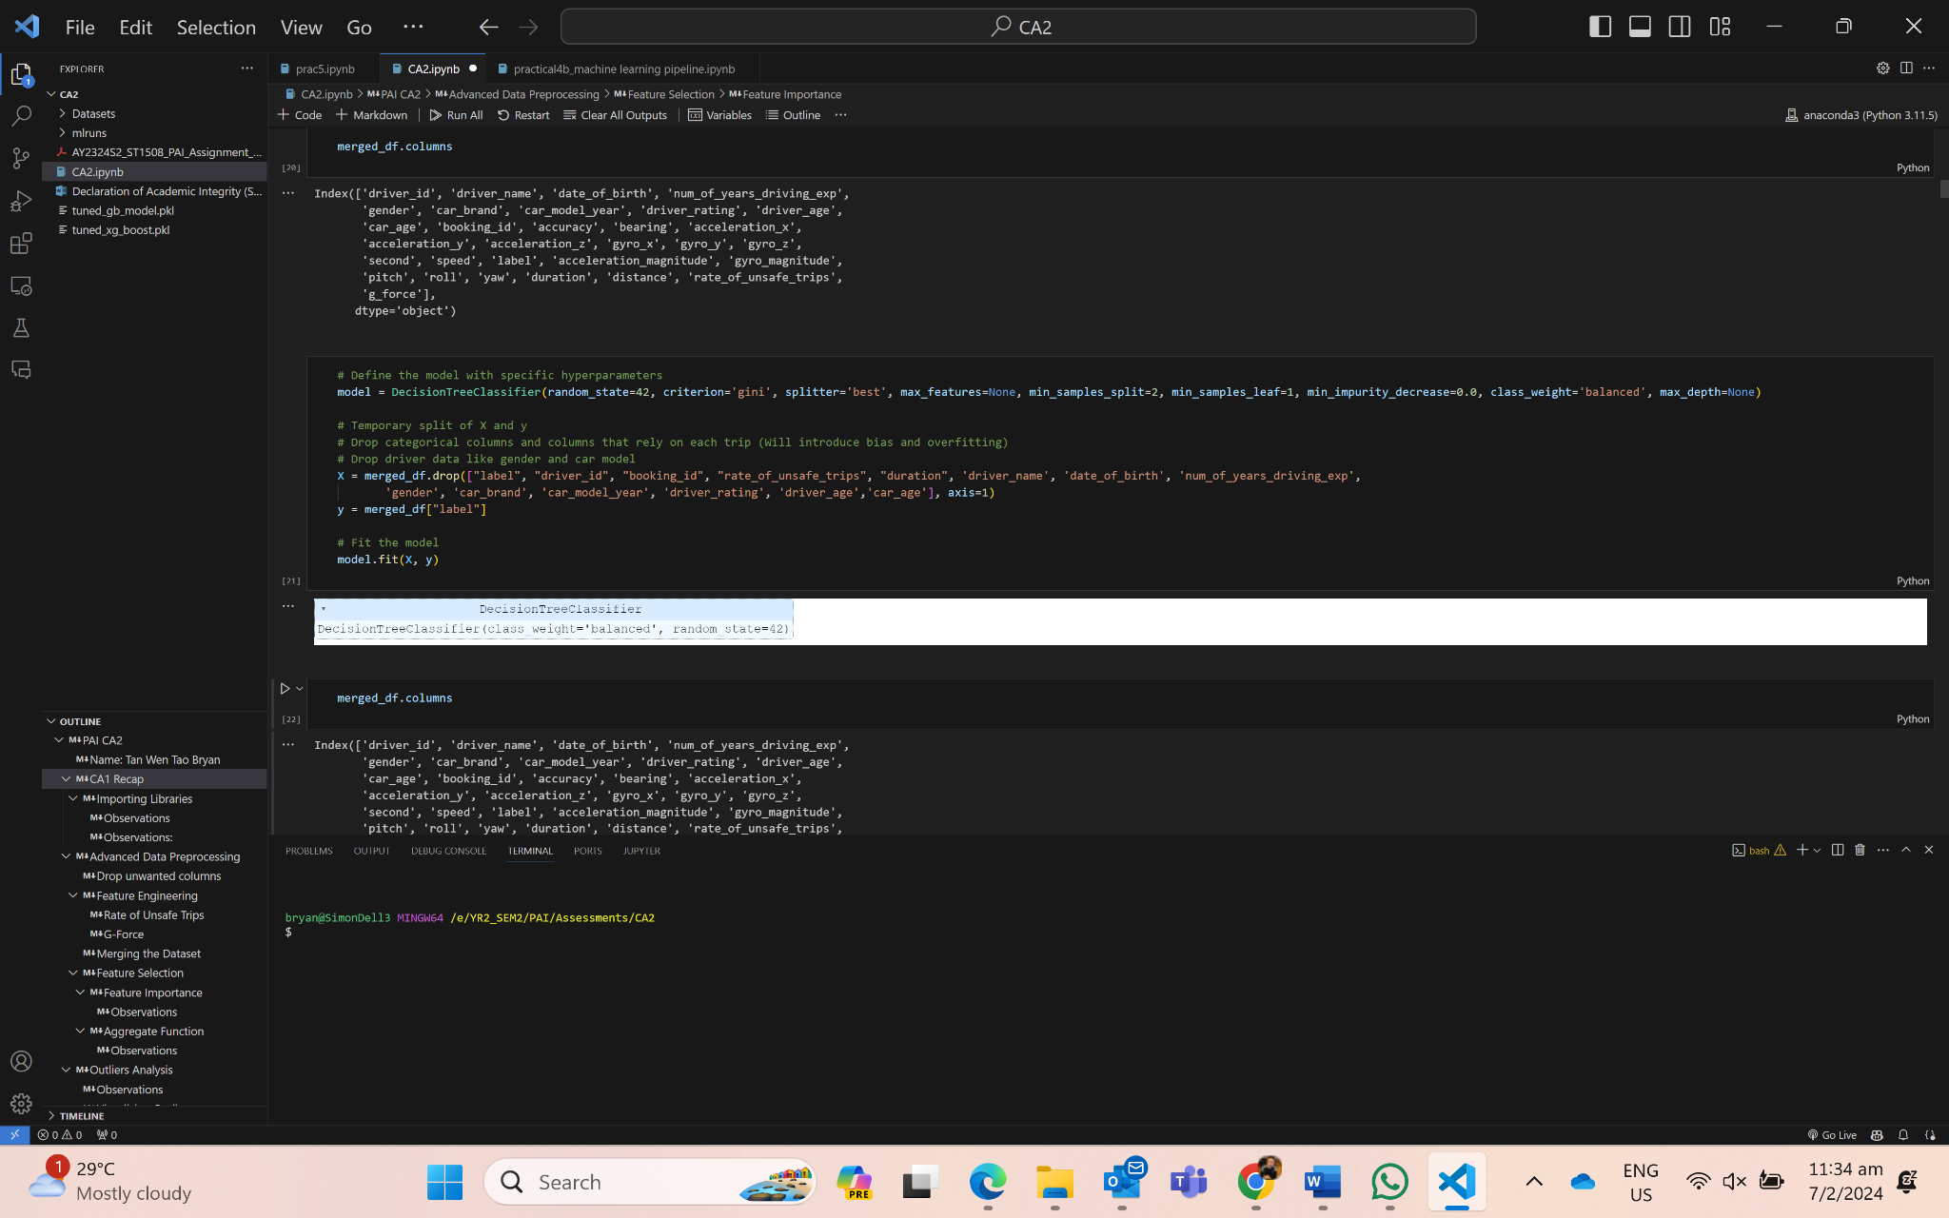

Feature Importance

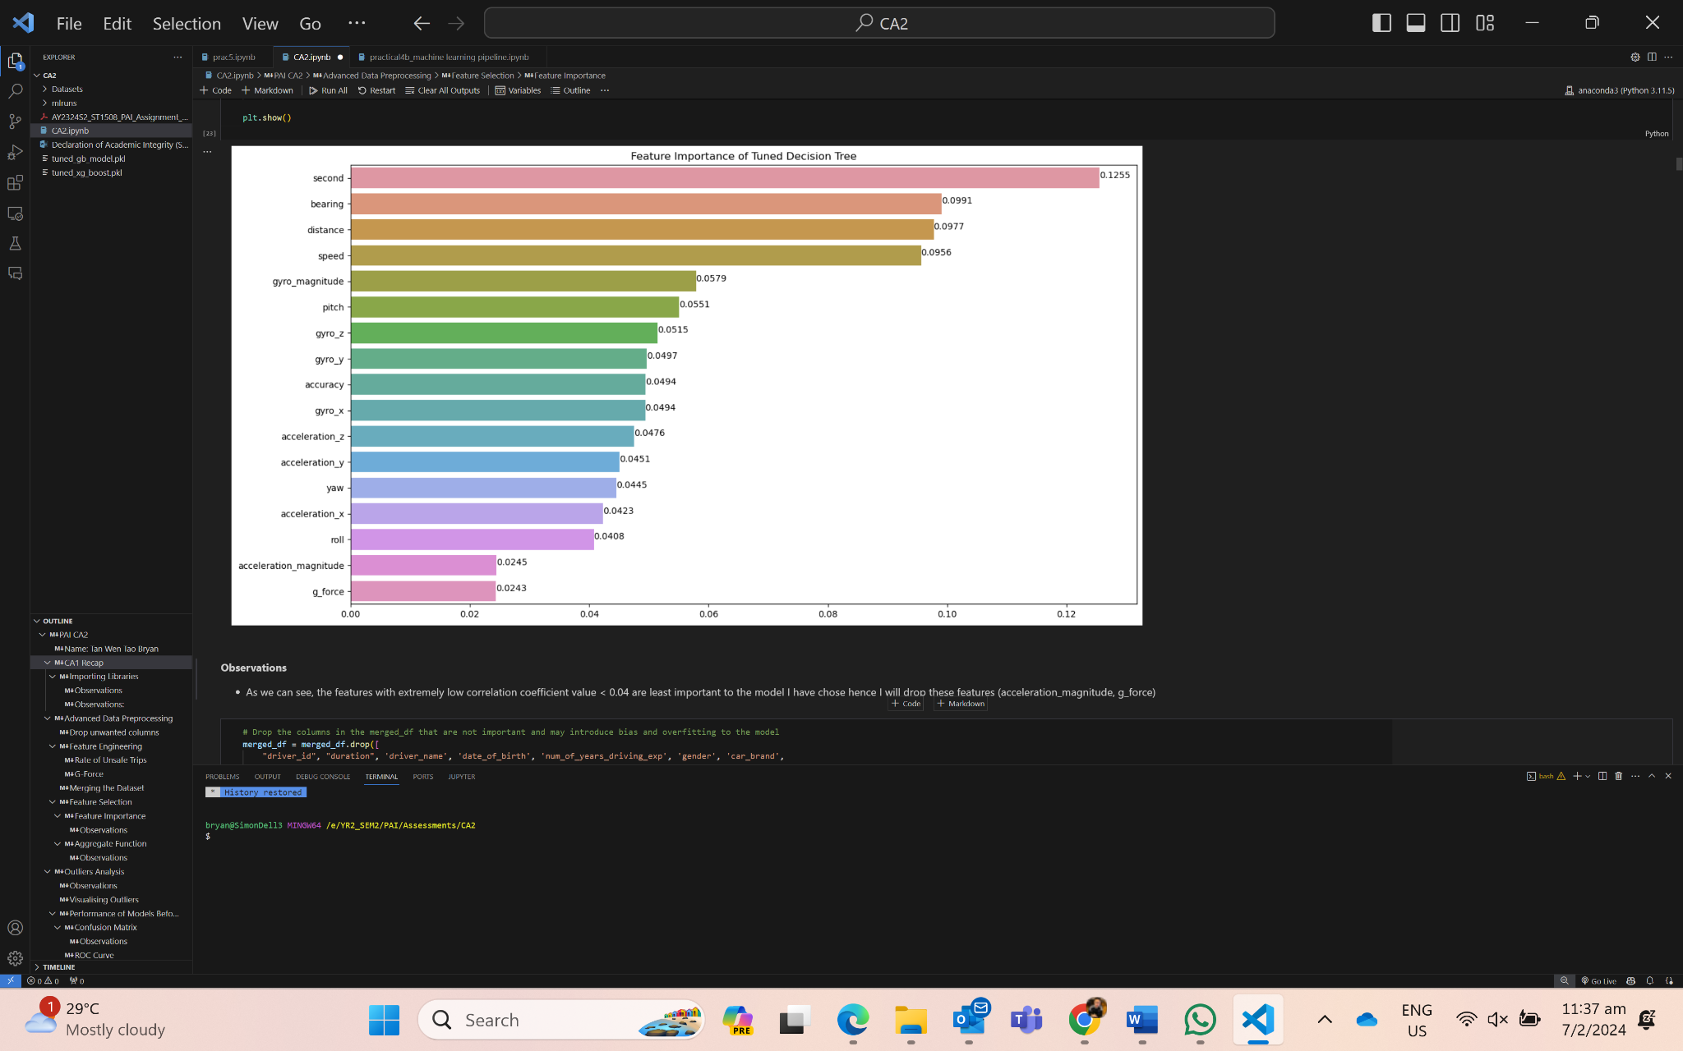

As such, the team will drop the acceleration magnitude, g_force as the coefficient is less than 0.04, as well as rate of unsafe labels due to it not being compatible with real time data. Another way of selecting the features is by using them to train the model and evaluating to see which subset of features provide the best results. As such, the number of features left is 15, excluding the index of booking_id and the output which is the label.

After using feature importance, we shall aggregate the data to reduce the rows of data to speed up the training time of the model, as well as to reduce the bias of the majority class of the label. The team calculates the mean values for each feature based on each bookingID. As such, the number of rows is reduced to 19972.

Aggregating mean values of the features based on bookingID

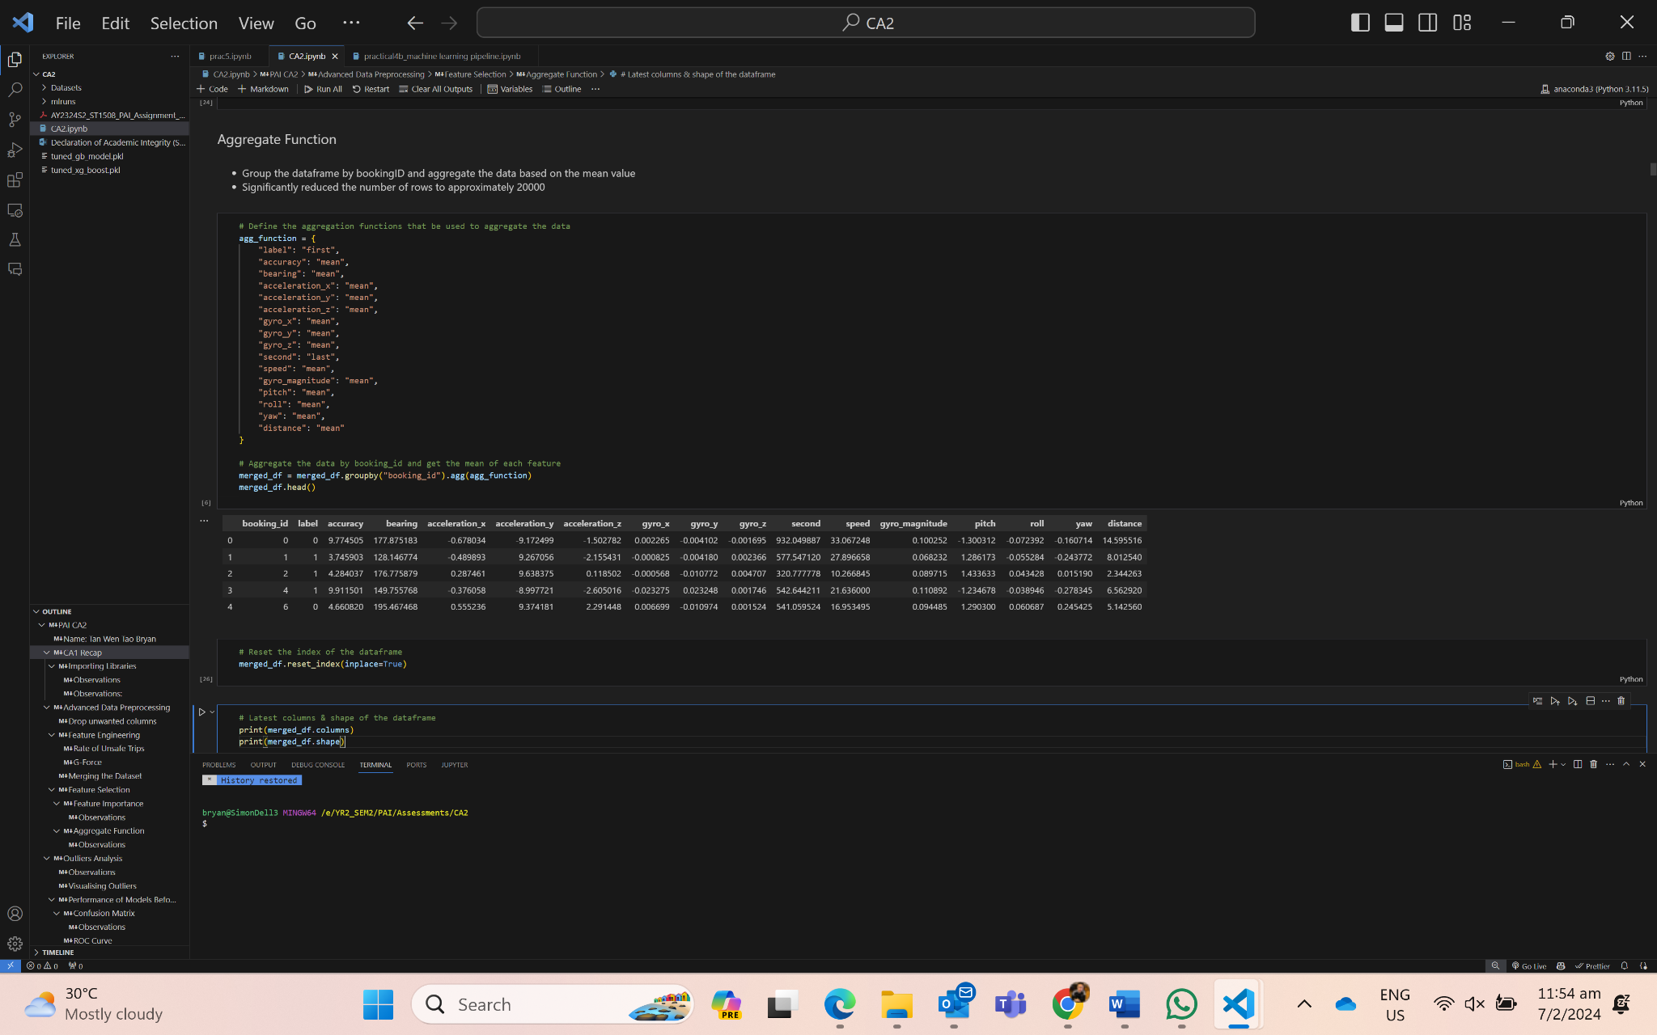

3.4 High-Dimensional Outliers Handling

Pairplot of the data

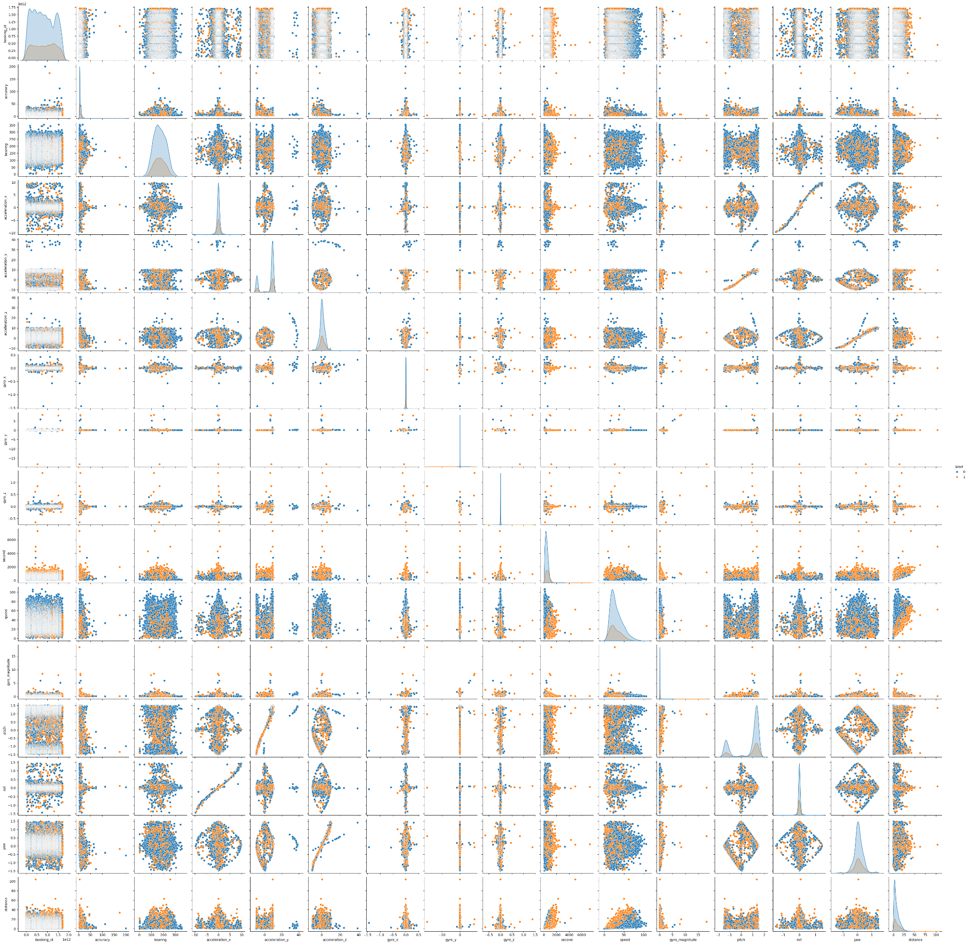

**Observations:**

We can see that there is a clear elliptical shape on some of the data, which will help us in the choice of the model to identify outliers later. (i.e. Elliptical Envelope)

High-Dimensional Outliers Detection Models Used

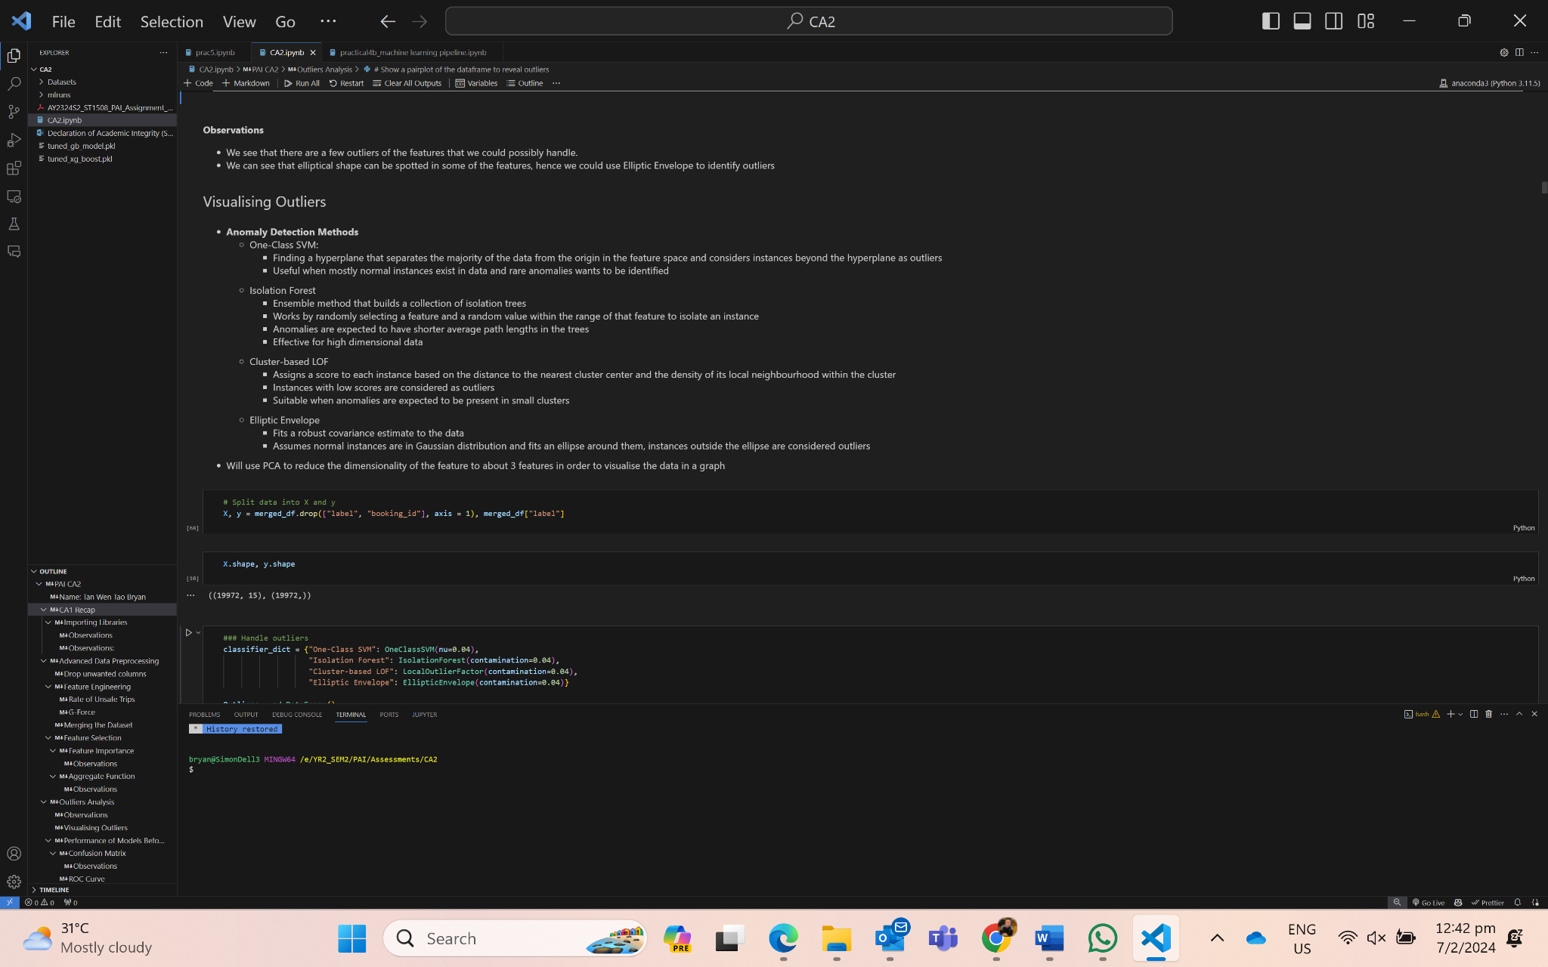

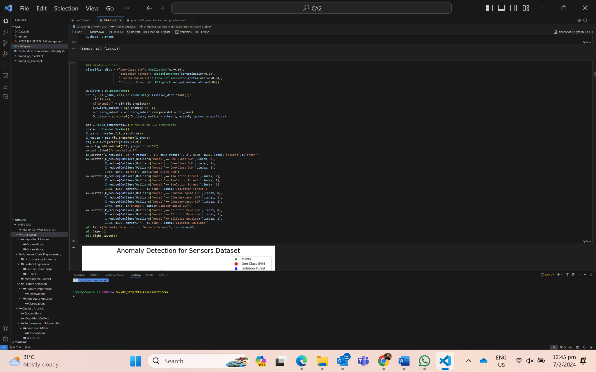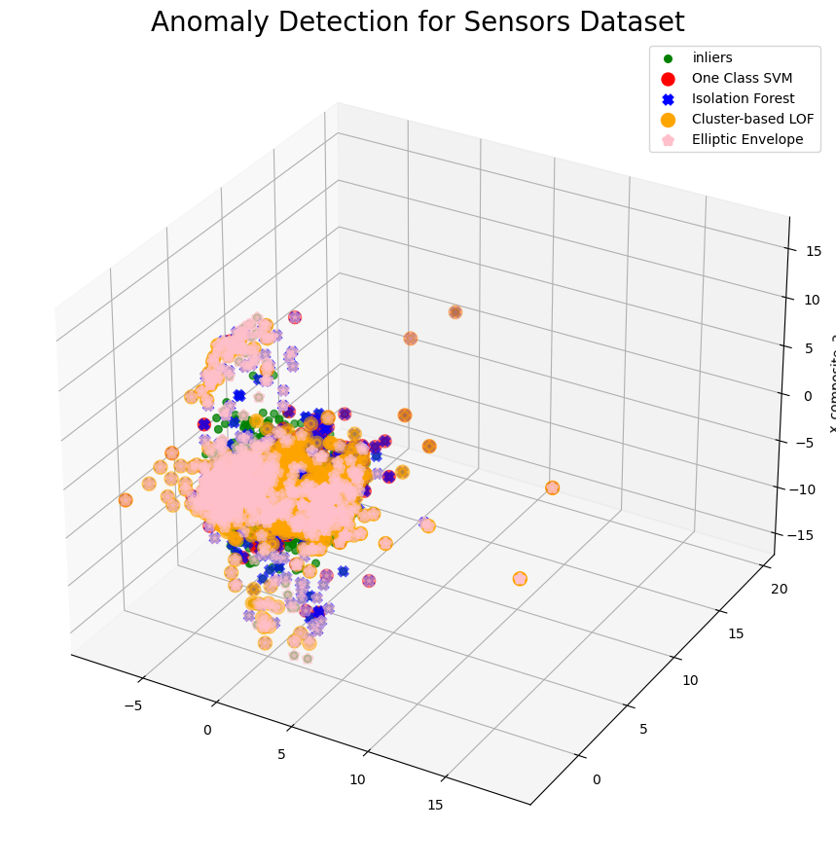

The results are shown below:

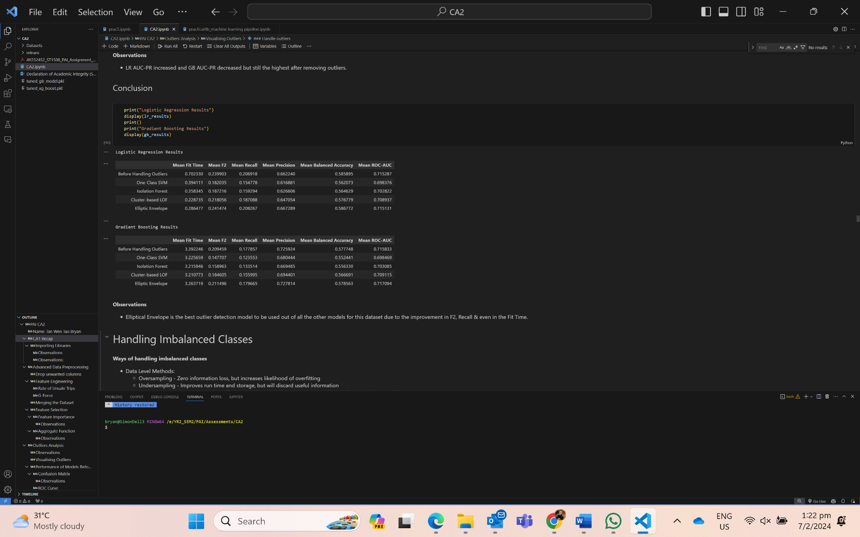

**Observations:**

According to the mean f2 and the mean recall score, it shows that only Elliptic Envelope is the best model as there is an improvement in the scores.

3.5 Handling Imbalanced Classes

Ways of Handling Imbalanced Classes

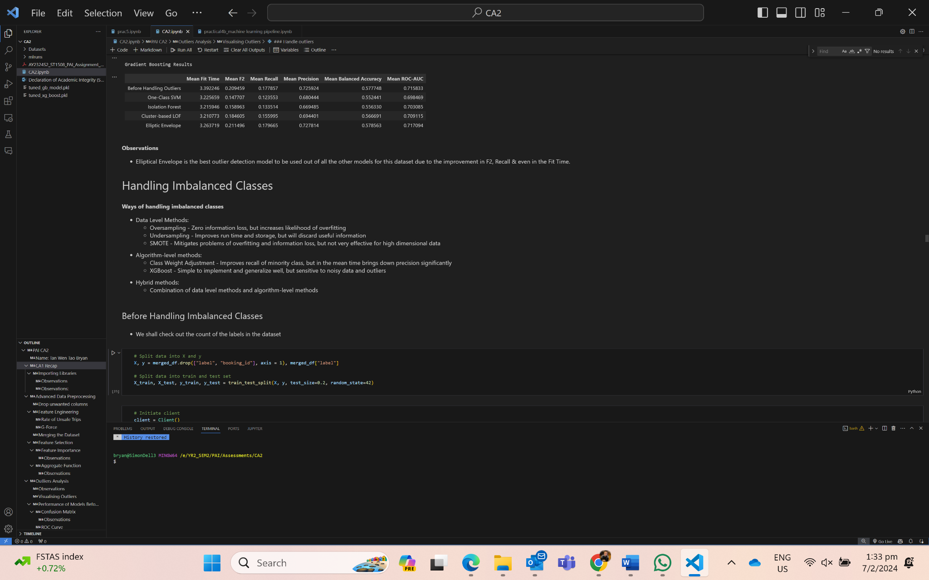

Before Handling Imbalanced Classes

When the target class is imbalanced, we have to handle the data as it may lead to the overfitting of the majority class. There is a greater percentage of safe labels than unsafe labels.

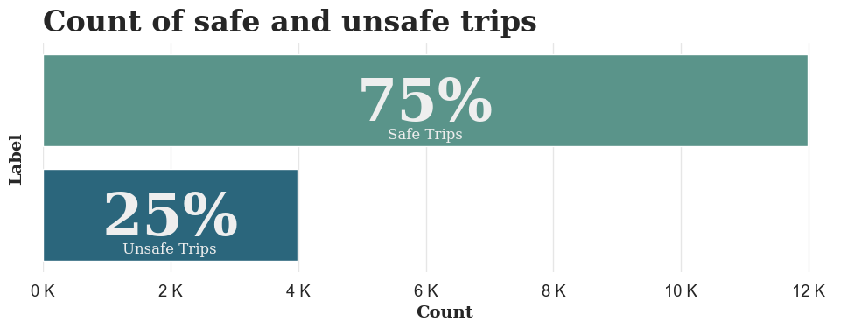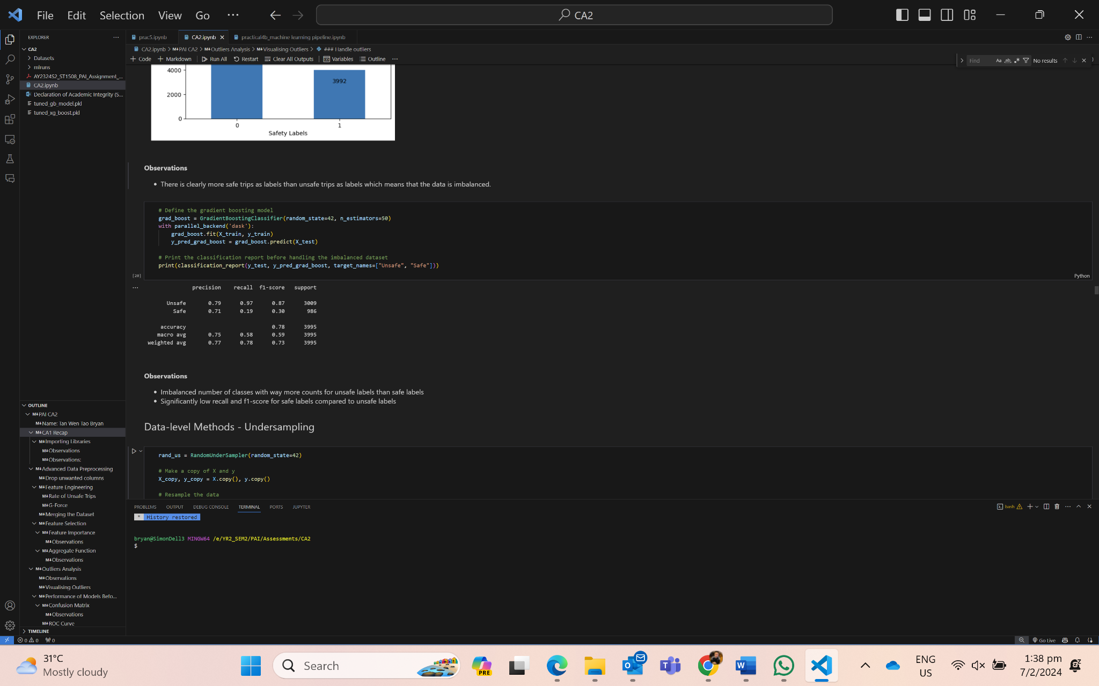

Undersampling Oversampling

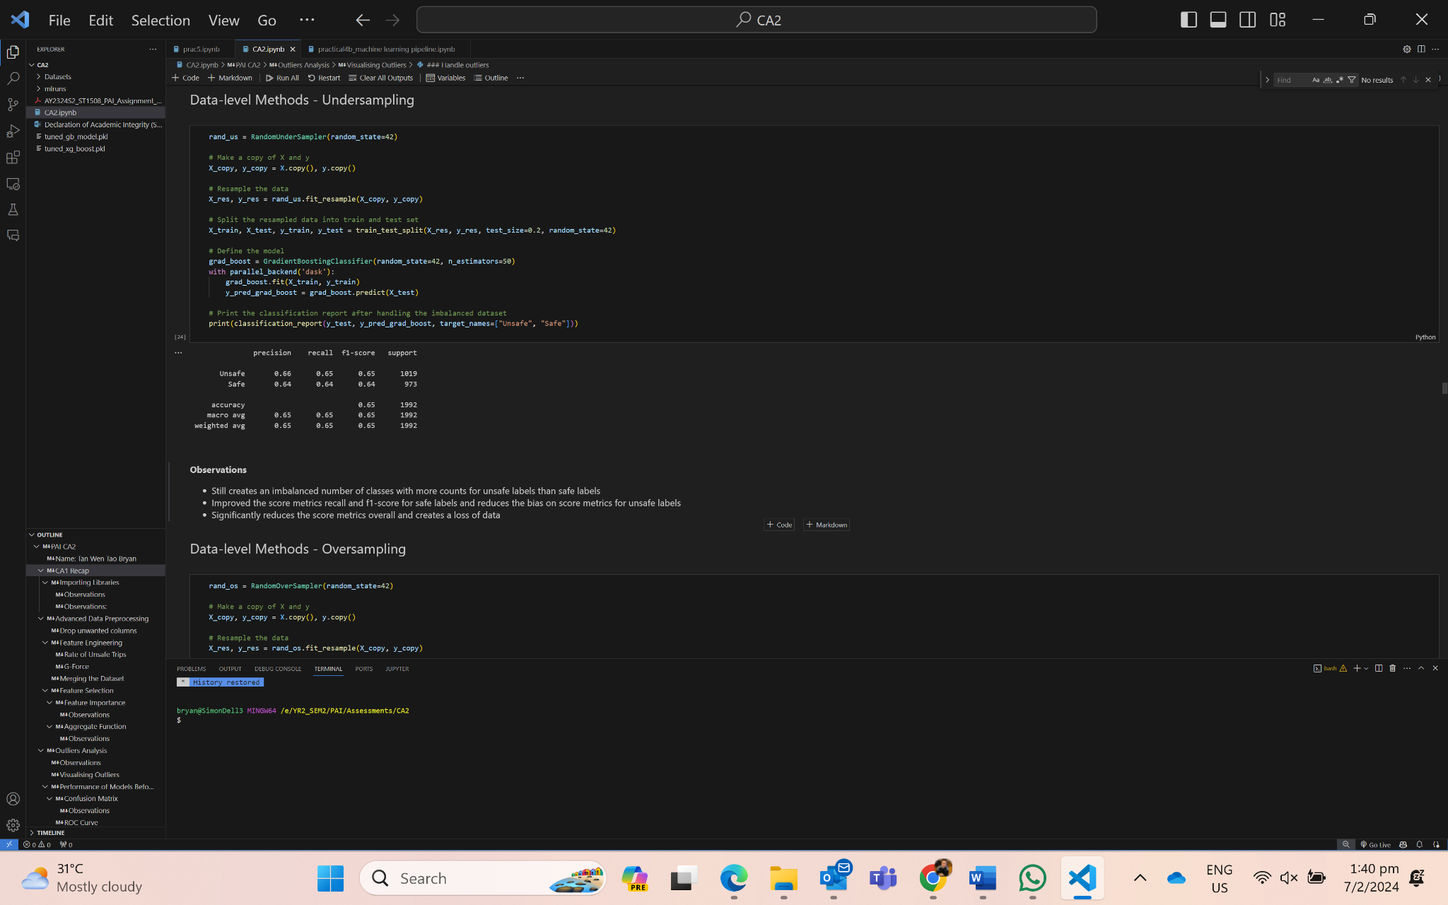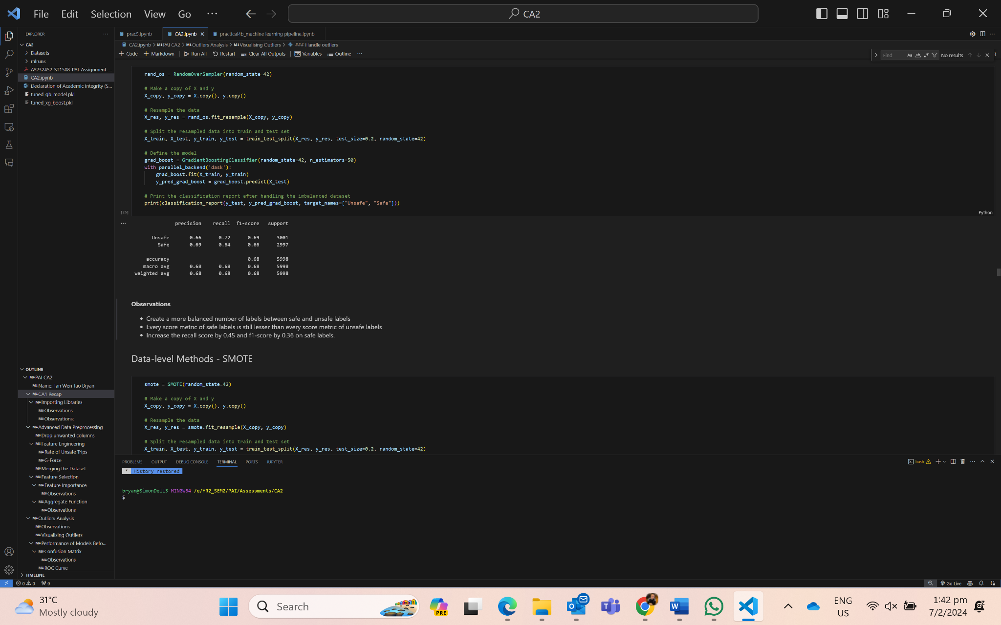

SMOTE Class Weight Adjustment

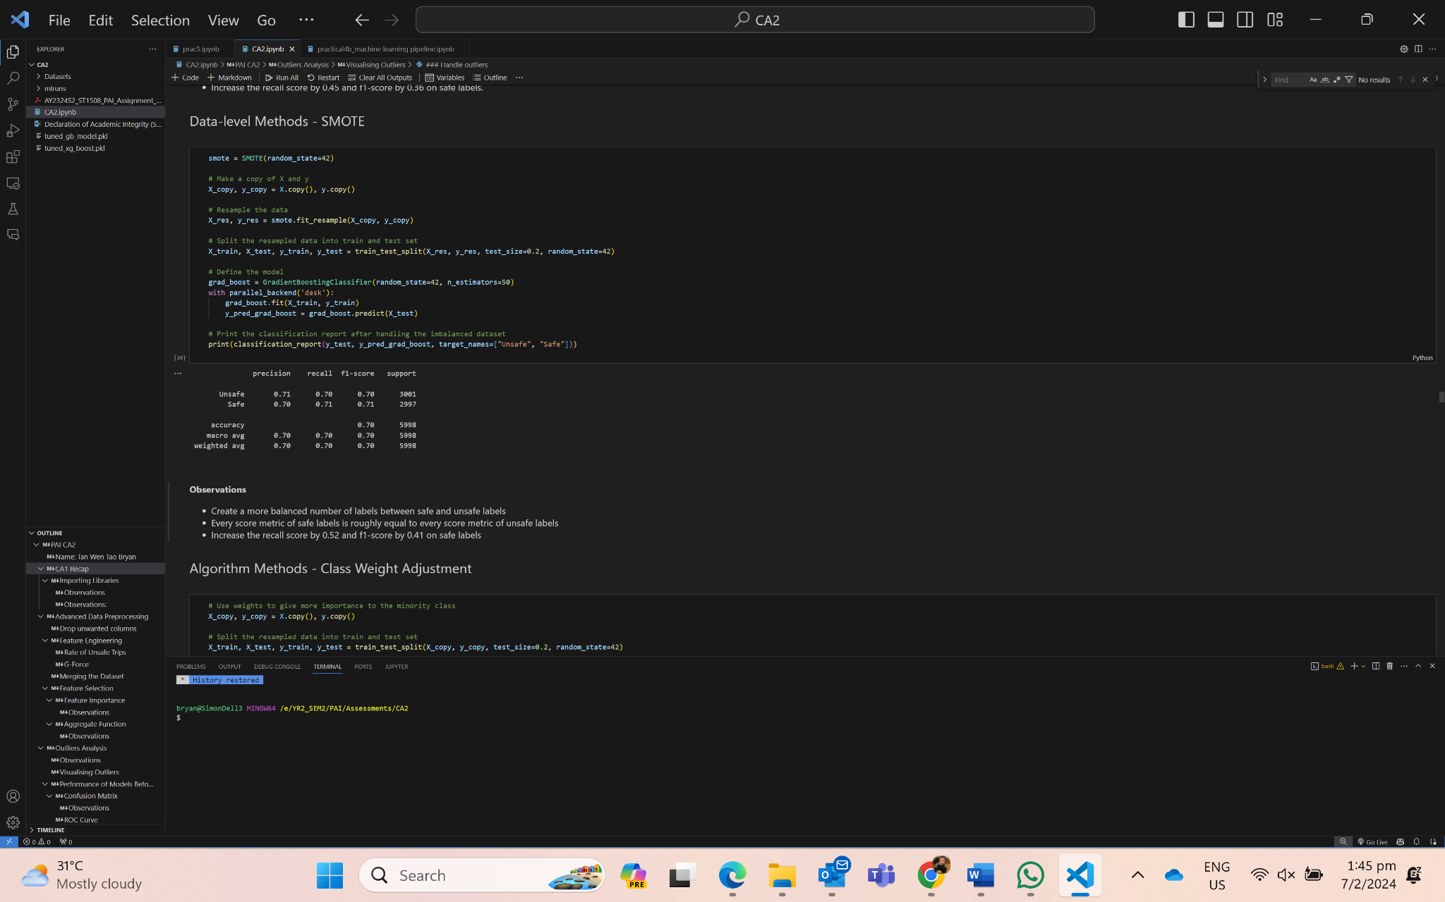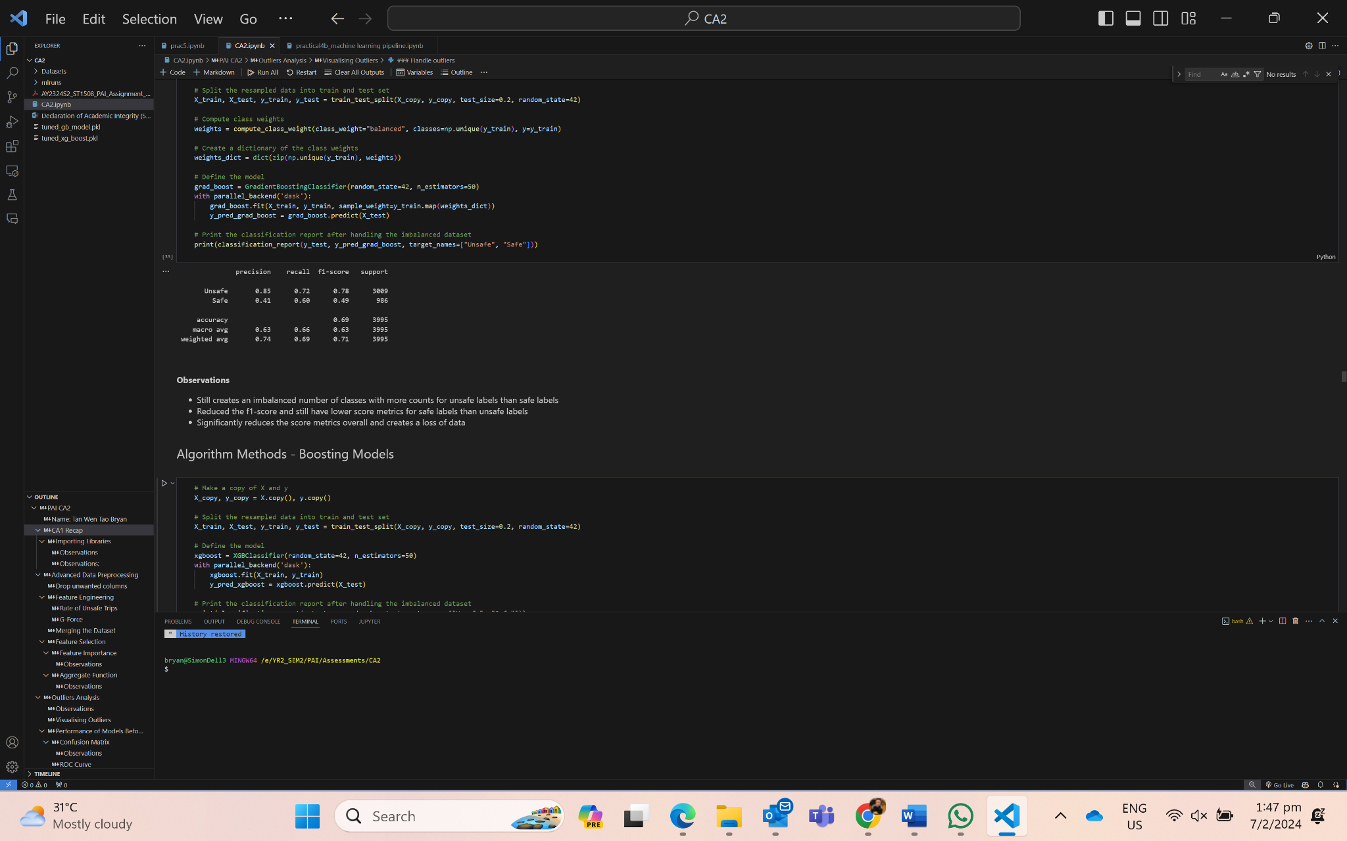

Boosting Models Hybrid Method - SMOTE + Adjust Weight

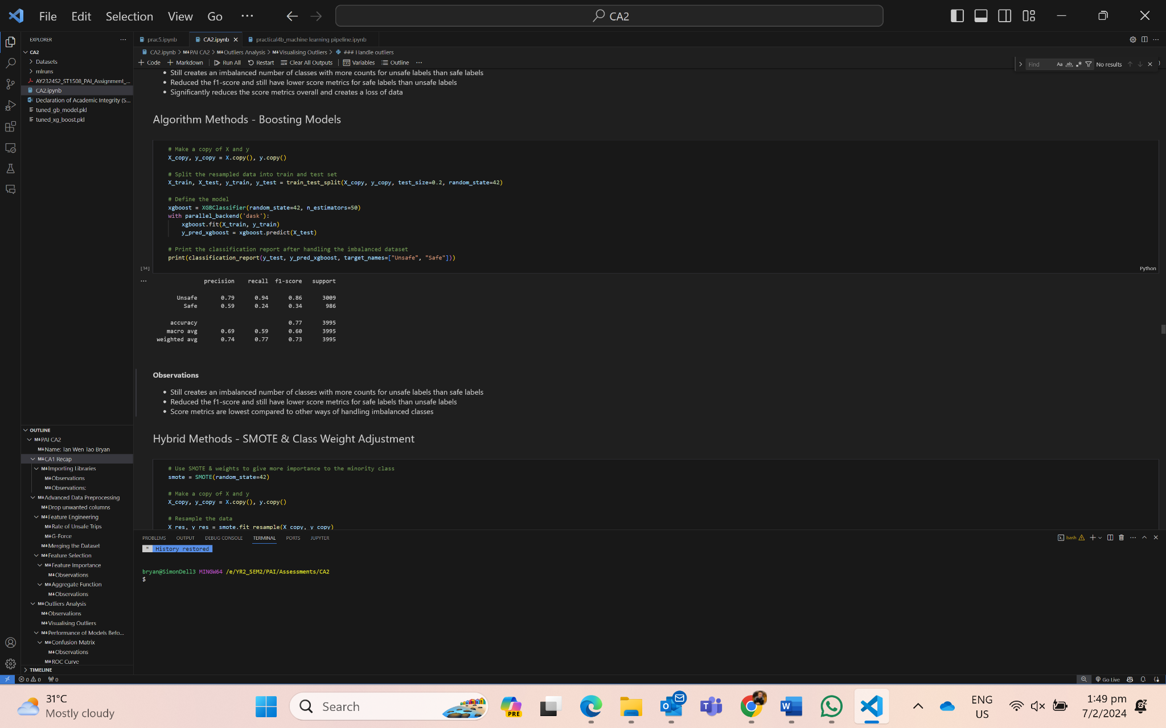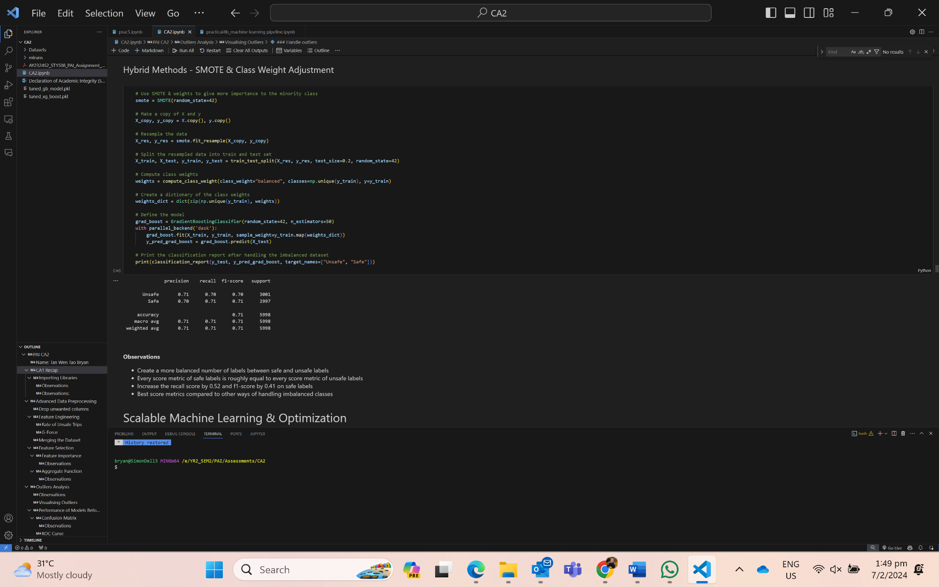

**Observations:**

Hybrid method is the best method to handle imbalanced weights. After using the model, there is a more balanced number of safe and unsafe labels. Every score metric for safe and unsafe labels are roughly the same and highest compared to other models. As such, using the hybrid method increased the recall score by 0.52 and f1-score by 0.41 for safe labels.

**4 SCALABLE MACHINE LEARNING AND OPTIMIZATION**

4.1 Model Development & Evaluation

Dask is a library with the features of parallelism and scalability that is useful for large datasets. Dask allows the team to **scale** computations down to make it possible to work with large datasets on a single machine, while providing **parallelism** computing capabilities which greatly reduce the time needed for each model training.

Instantiating Dask Client

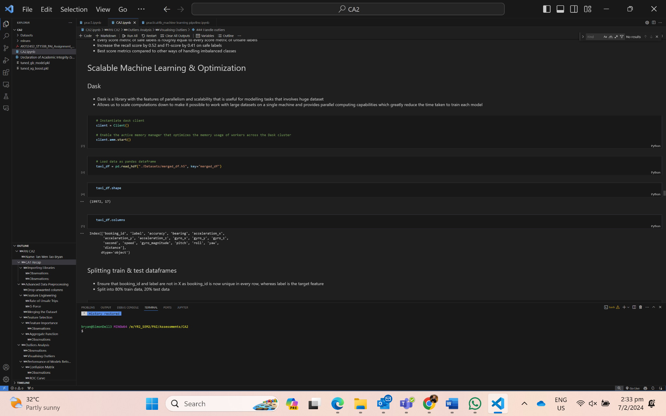

Split train & test - 4:1 (80%:20%)

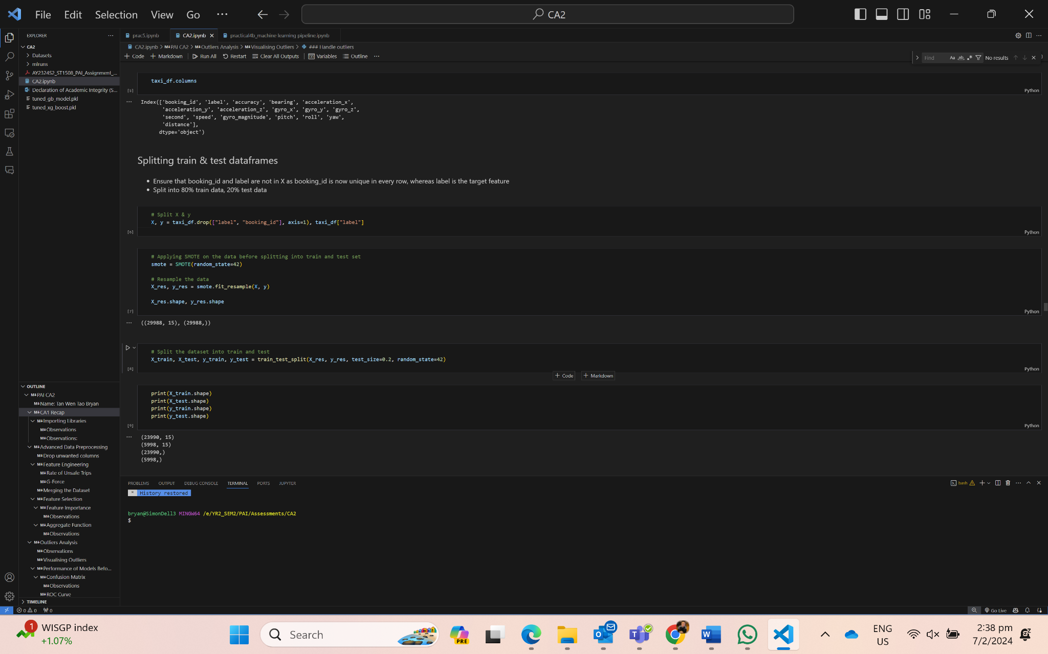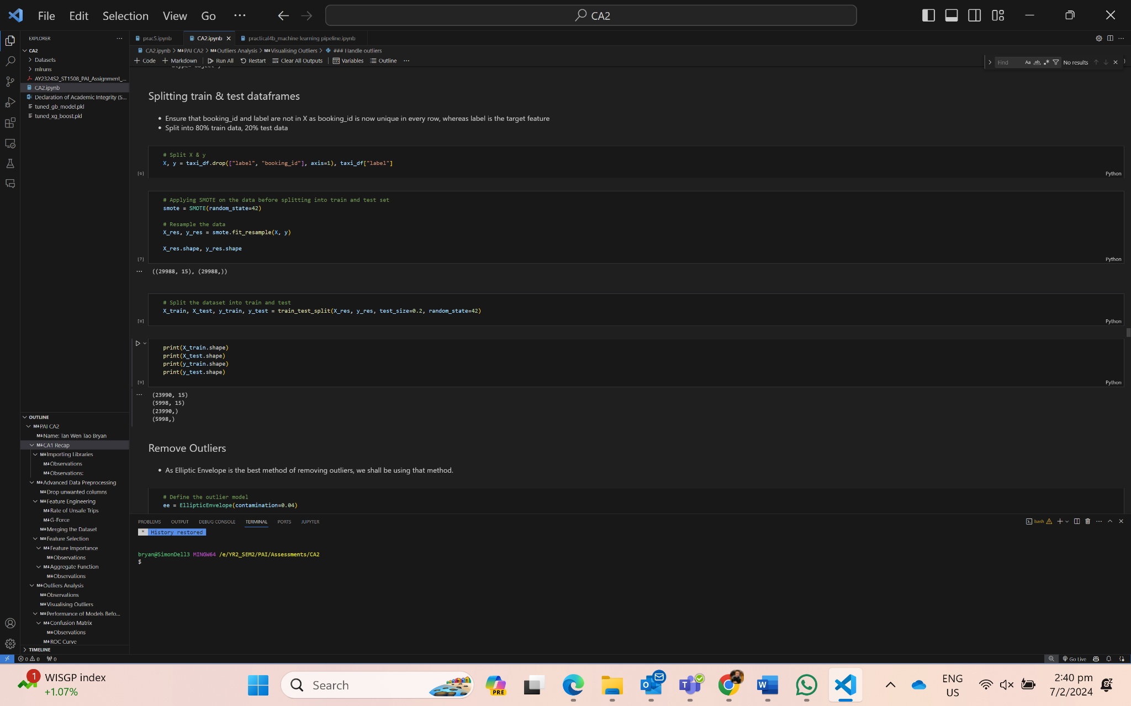

Next, we removed the outliers using the best outlier handling model, Elliptic Envelope.

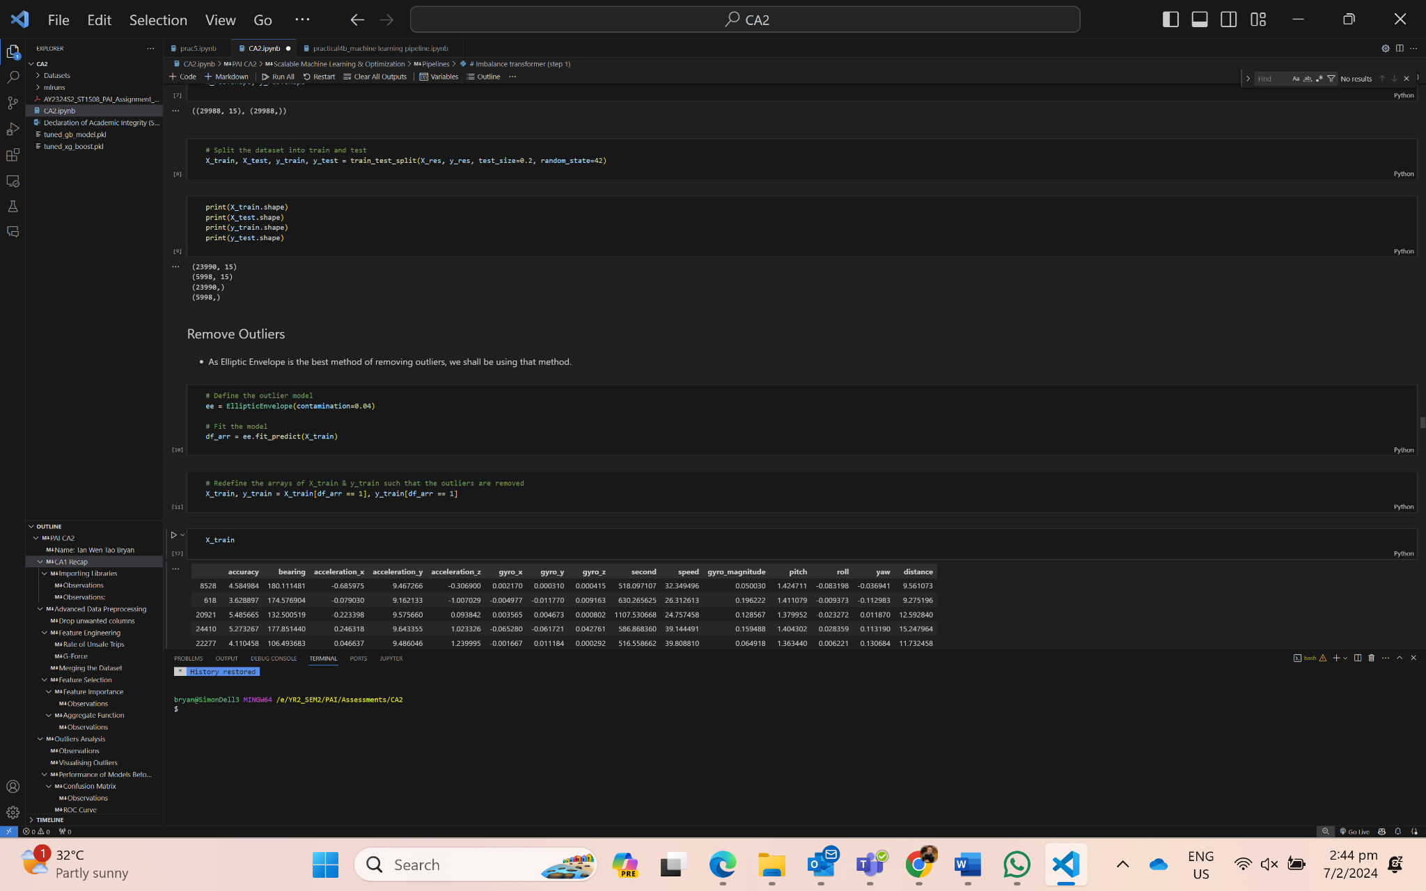

Creating a pipeline

Creating a pipeline allows the team to streamline the machine learning process by compiling the preparation and transformation steps, which ensure consistency and automate repetitive tasks. The pipeline includes using SMOTE, StandardScaler and the model. Everytime the model is being trained, it would run through the same pipeline.

The team also adjusted the weights such that the minority class would have higher weight, while the majority class had a lower weight computed on it.

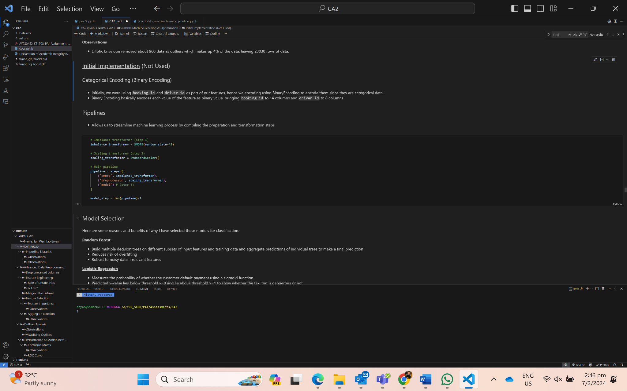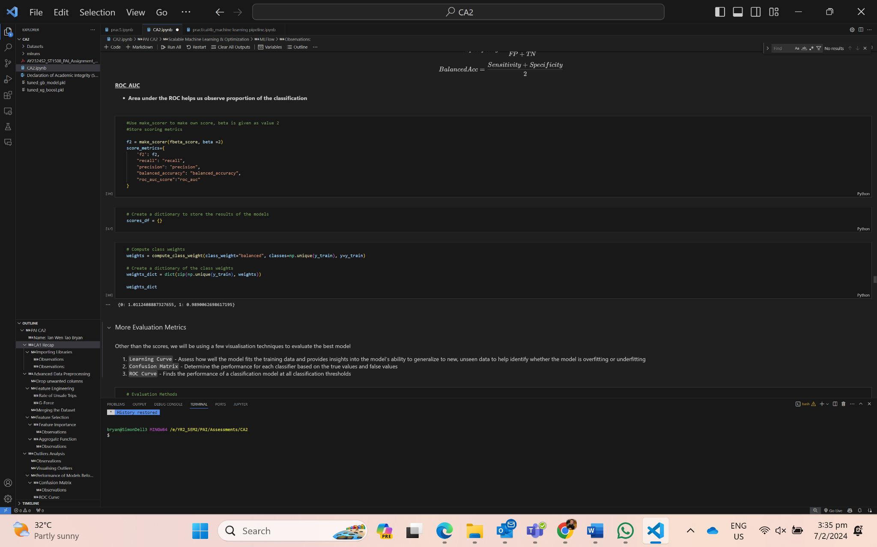

Model Selection - Train a few models and find out the best model

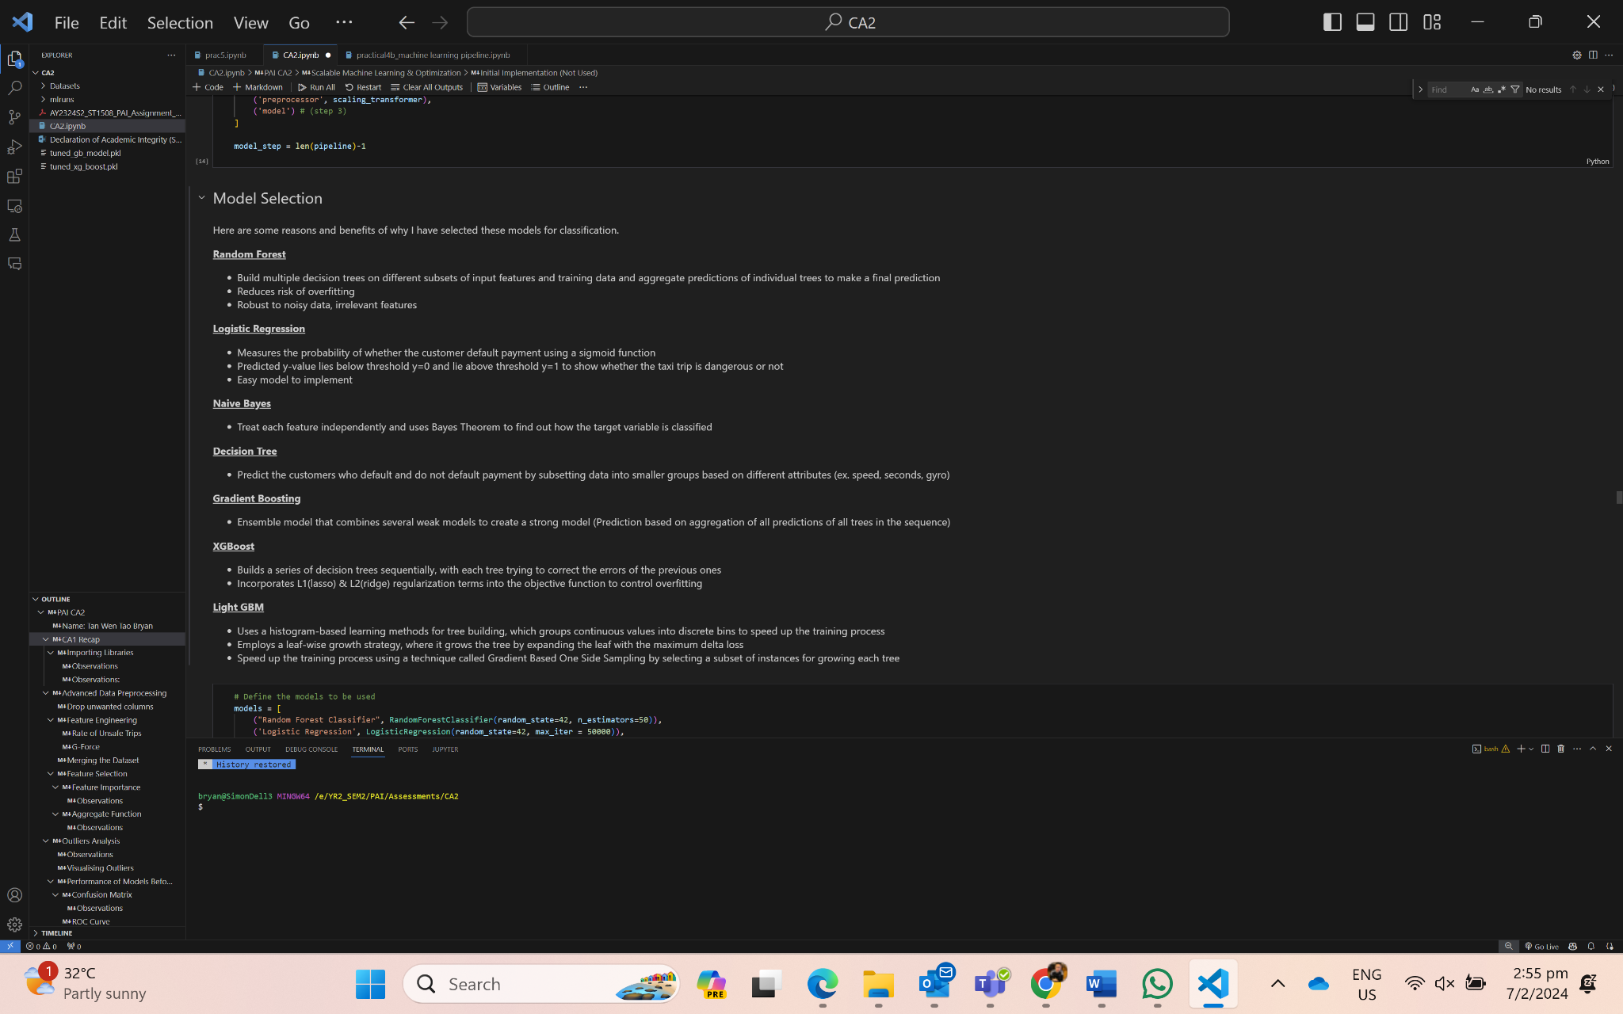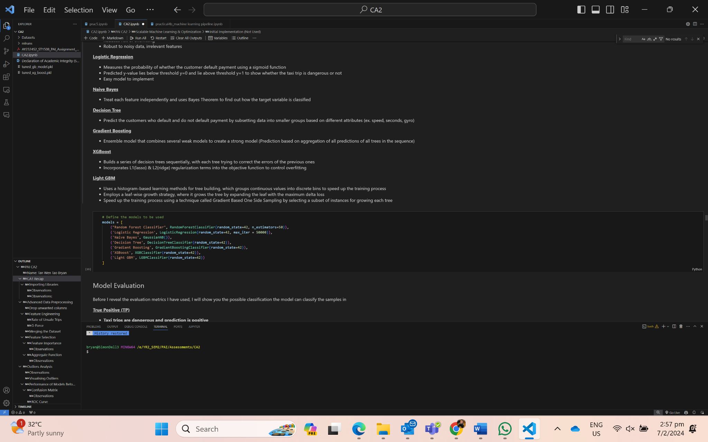

Model Evaluation - Main metric (F2 Score)

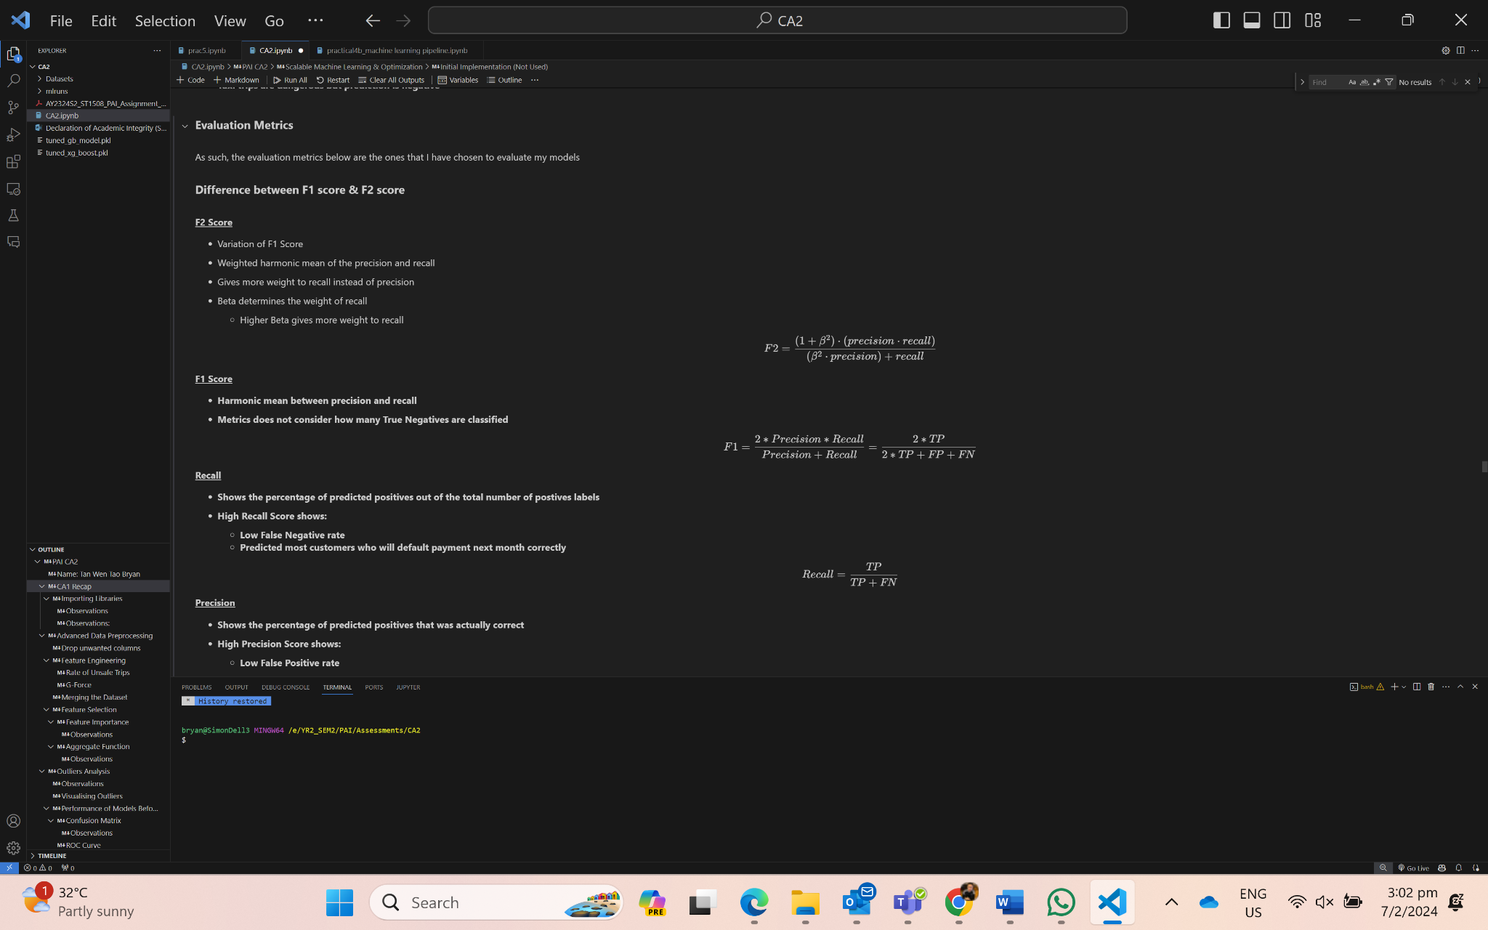

Other Score Metrics - (Recall, Precision, Balanced Accuracy, ROC-AUC)

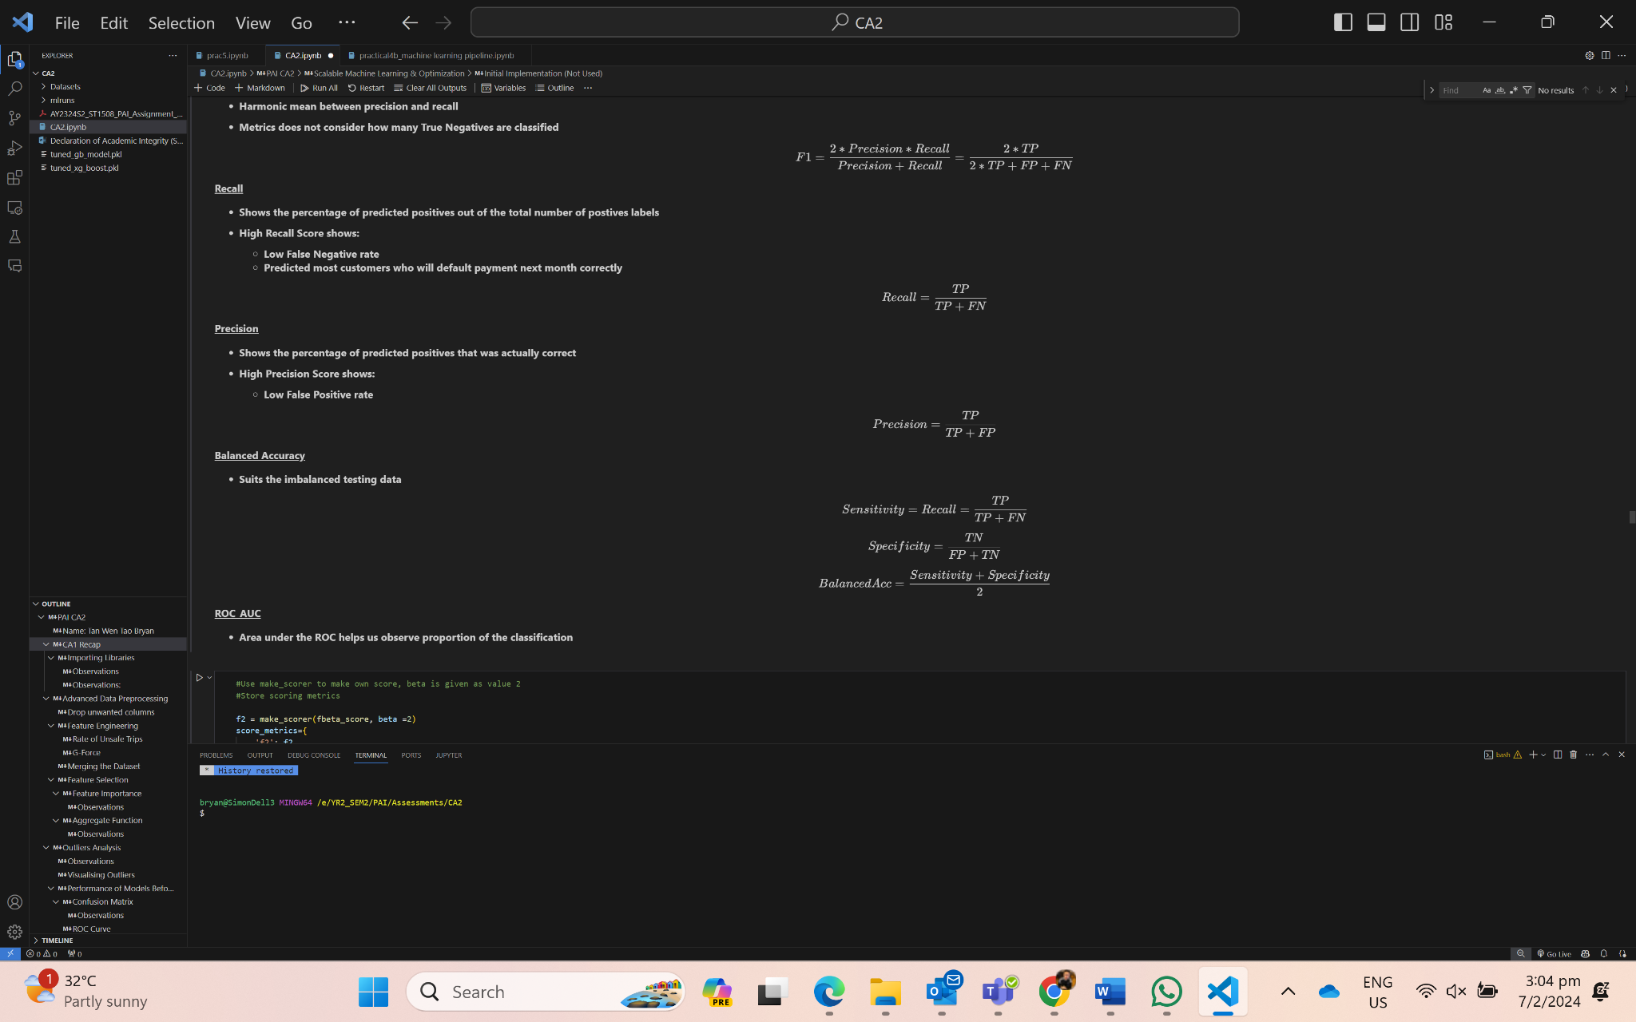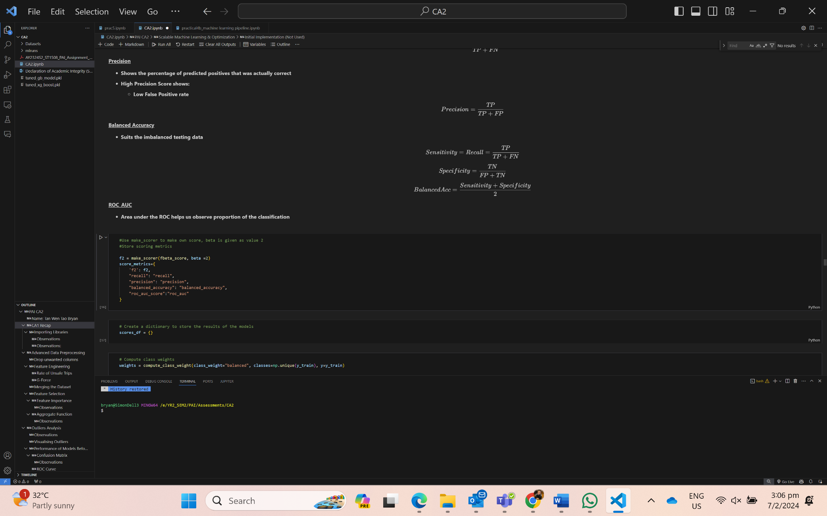

Learning Curve, Confusion Matrix, ROC curve

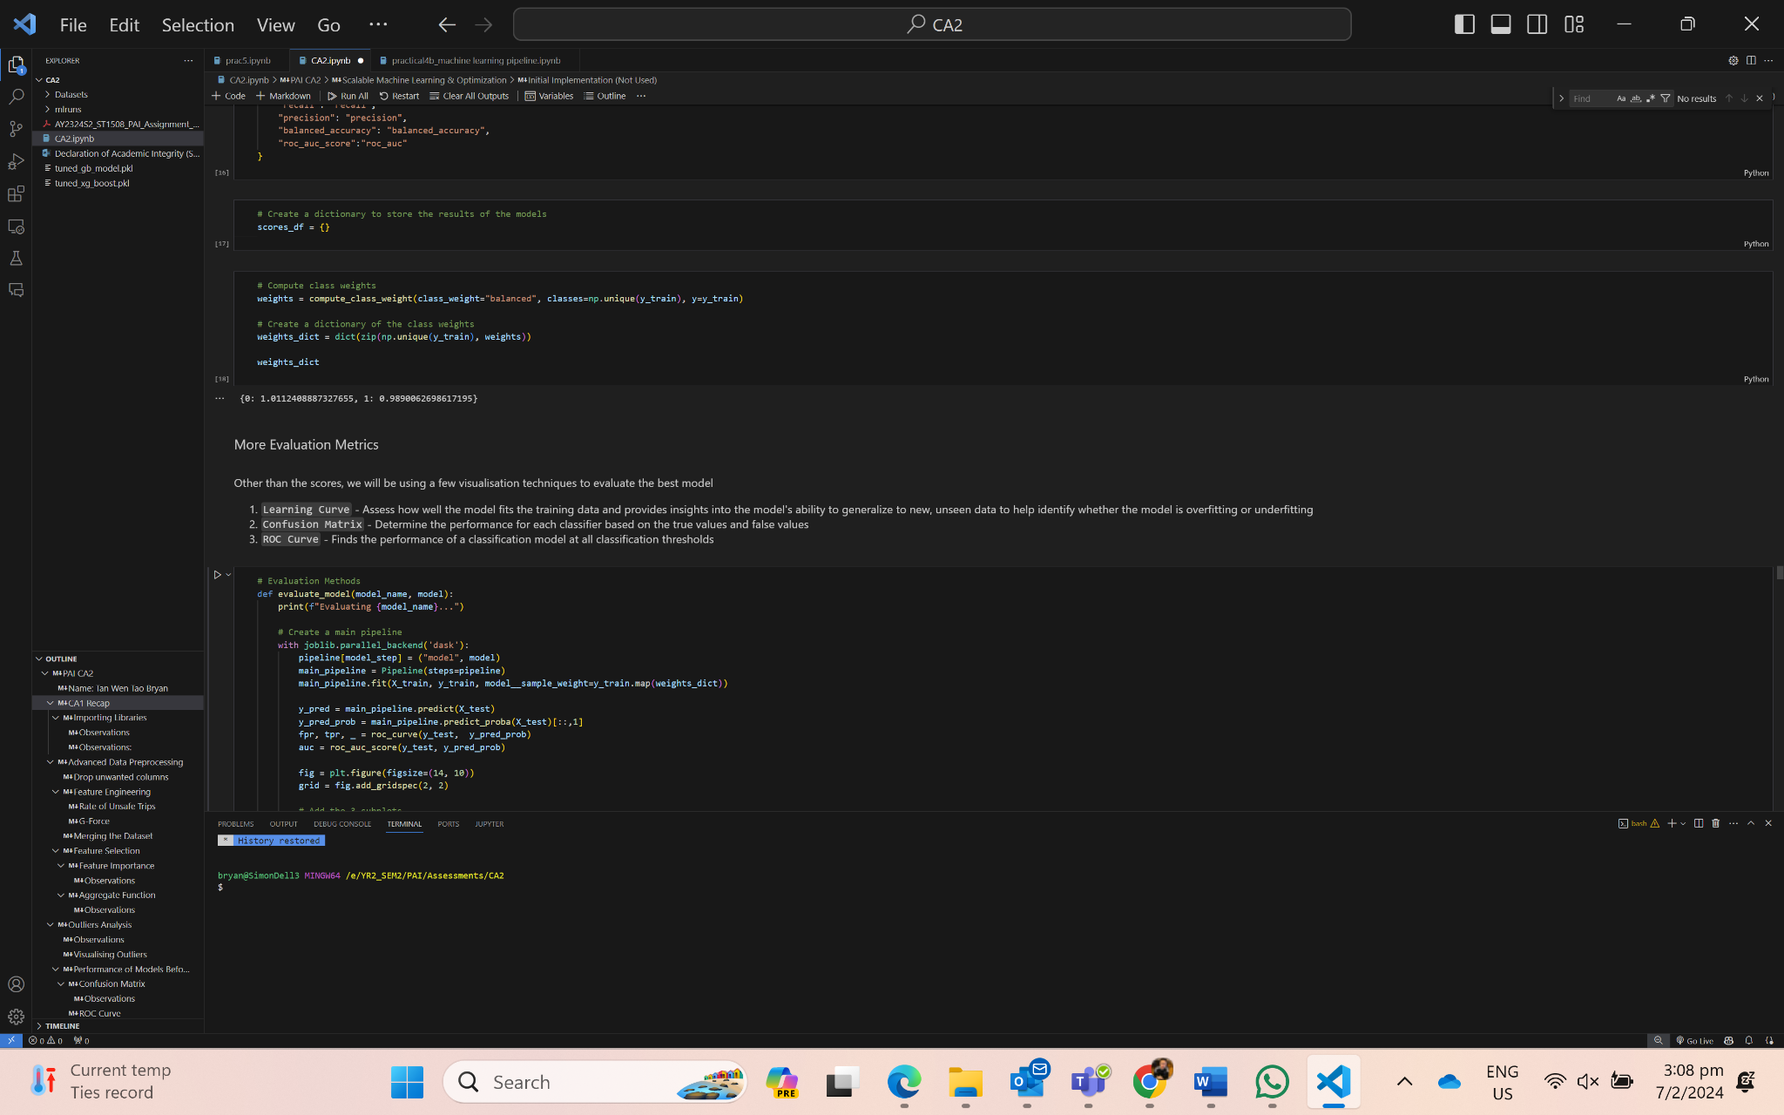

As the team is training the models, we should log in the model, the params and the metric into MLFlow to help with tracking and monitoring to evaluate the best model.

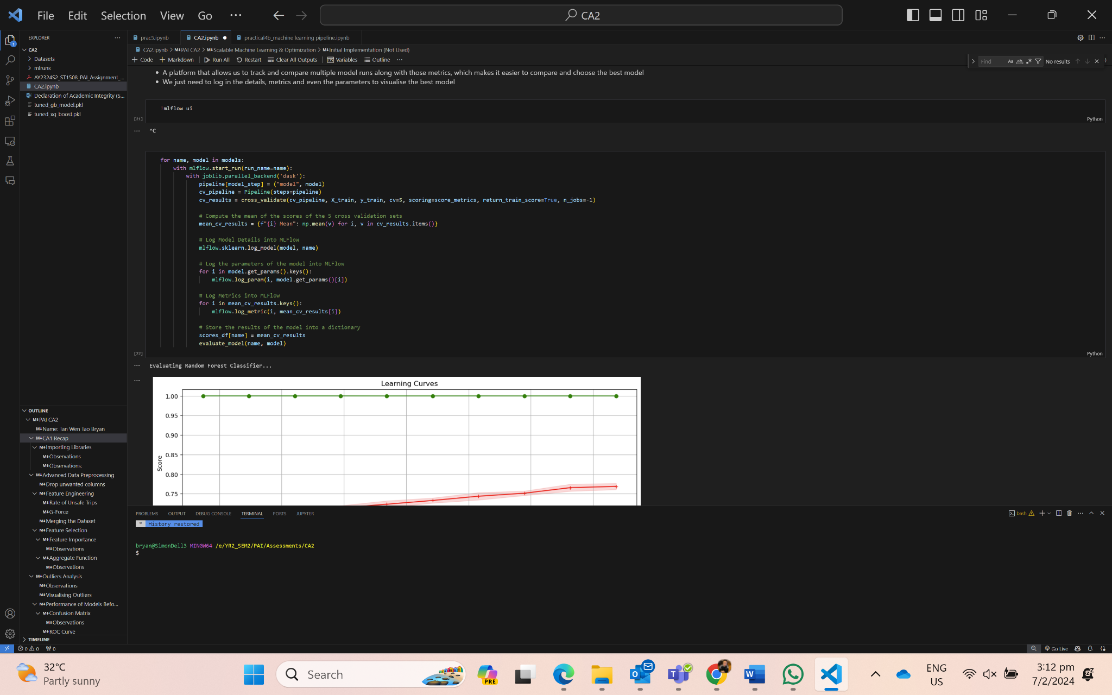

Random Forest Classifier Gradient Boosting

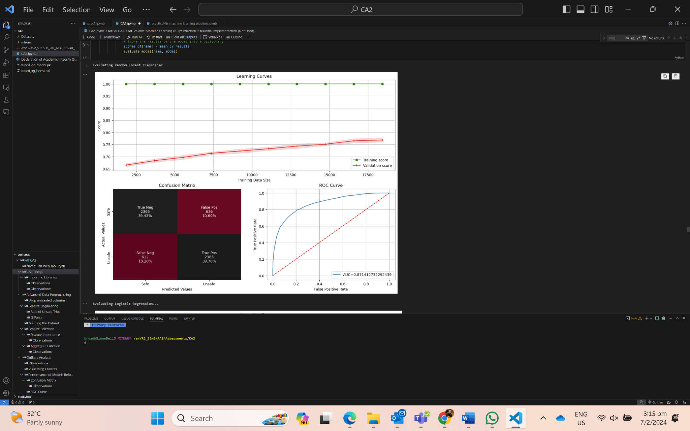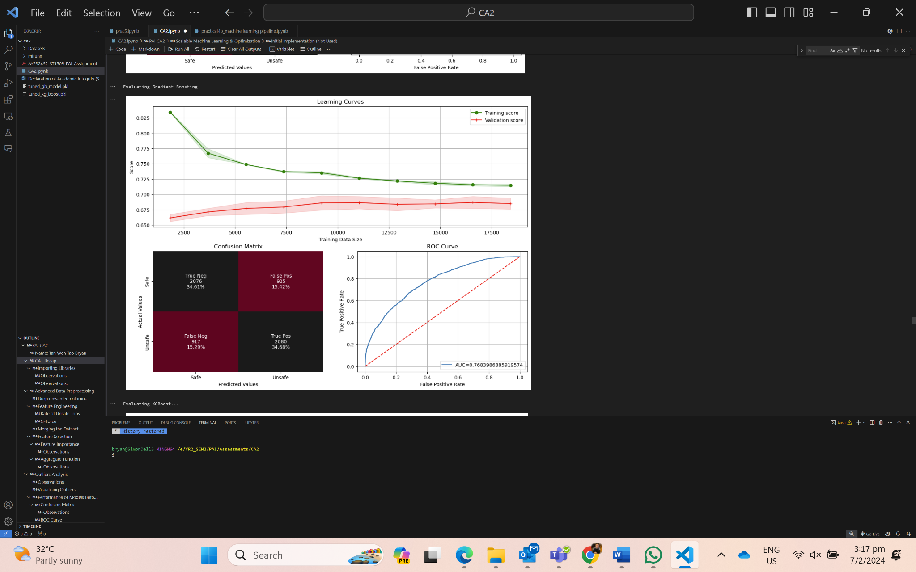

XGBoost LightGBM

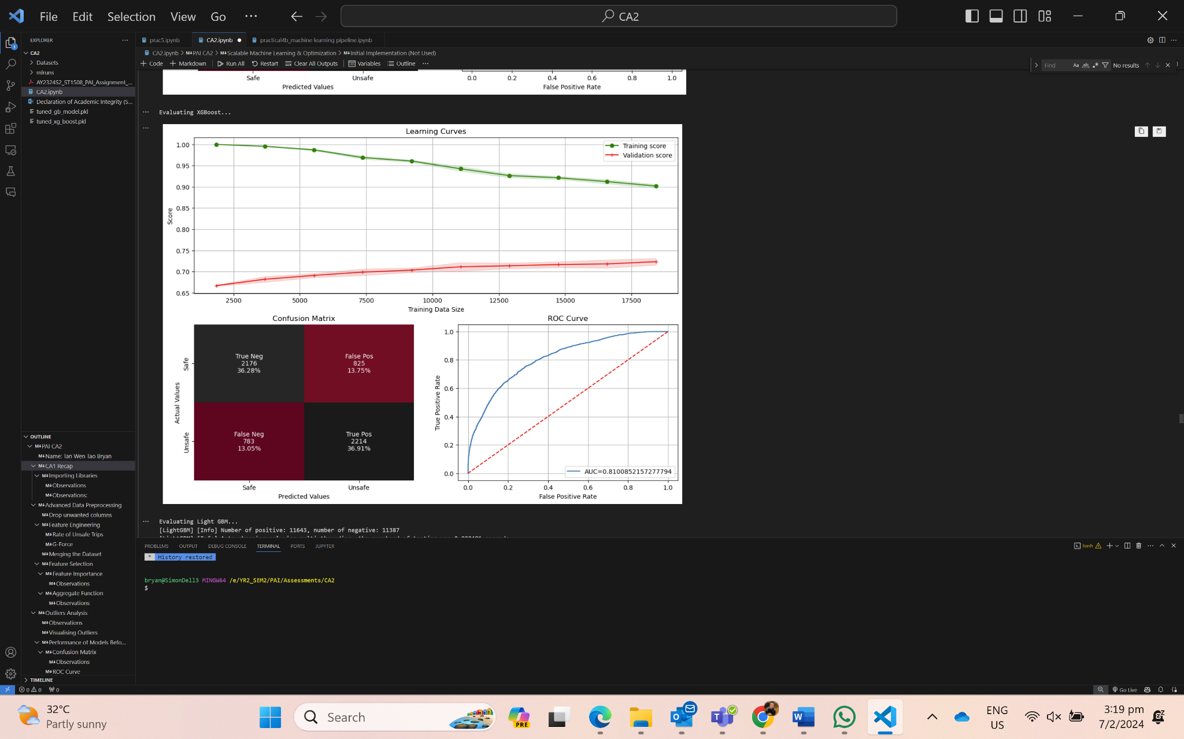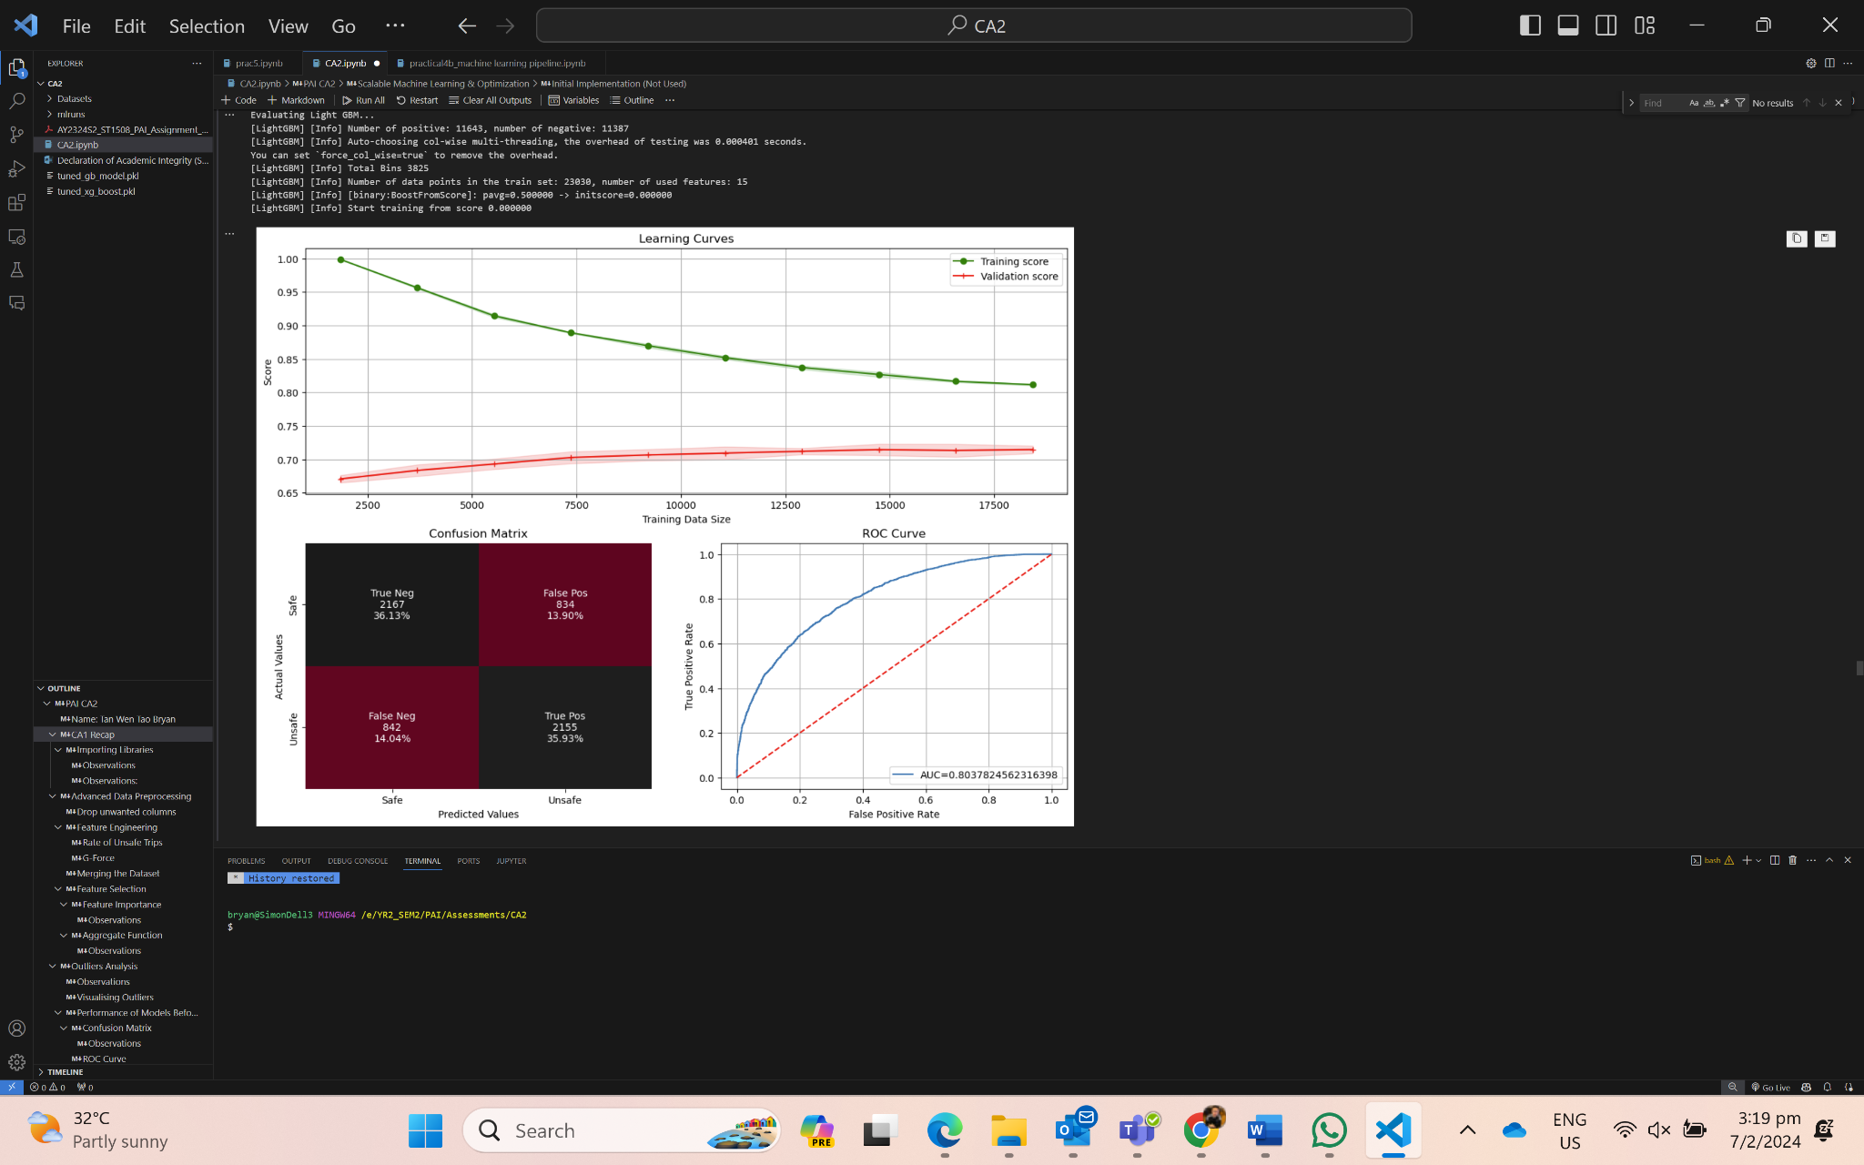

**Observations:**

- Visually, it looks like the validation score increased in the learning curve graph as the data size increased for these models (Random Forest, Gradient Boosting, XGBoost, LightGBM), showing that the models are learning.

- Training score for Random Forest is definitely overfitted but the validation score seems that it is learning from the data.

- According to the confusion matrix, Random Forest has the most number of True Positives and True Negatives compared to the False Positives and False Negatives, followed by XGBoost.

- AUC-ROC shows that Random Forest is the best model, followed by XGBoost and LightGBM.

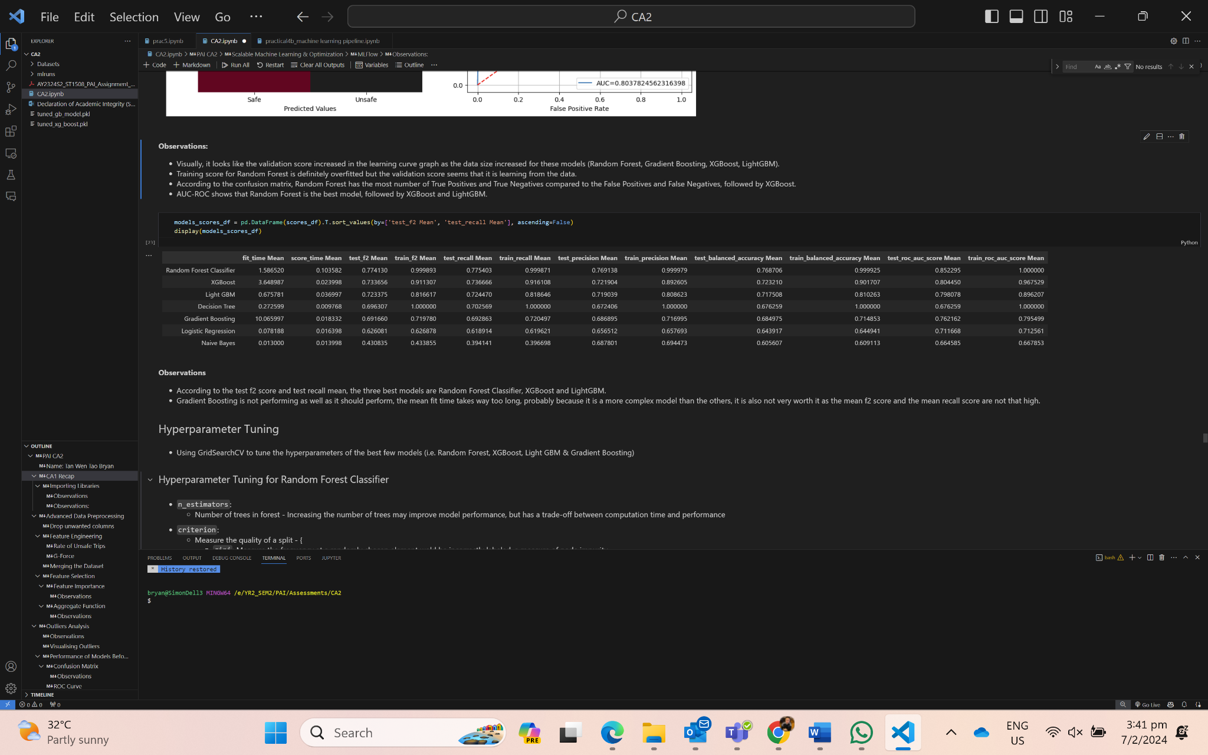

**Observations**:

- According to the test f2 score and test recall mean, the three best models are Random Forest Classifier, XGBoost and LightGBM.

- Gradient Boosting is not performing as well as it should perform but we shall try to improve it too and see if the scores improved.

4.2 Model Optimization

After selecting the best 4 models, we have decided to use GridSearchCV which plays an important role in optimizing machine learning models by exploring a hyperparameter grid. This cross-validated search efficiently identifies the optimal hyperparameter combination, maximizing on each model performance metrics. We can use GridSearchCV to ensure that each model is fine tuned for optimal accuracy across the datasets, due to the computational and time complexity for most models. We will use GridSearchCV to see which model parameters output the best f2 score.

Hyperparameter Tuning - Random Forest Classifier

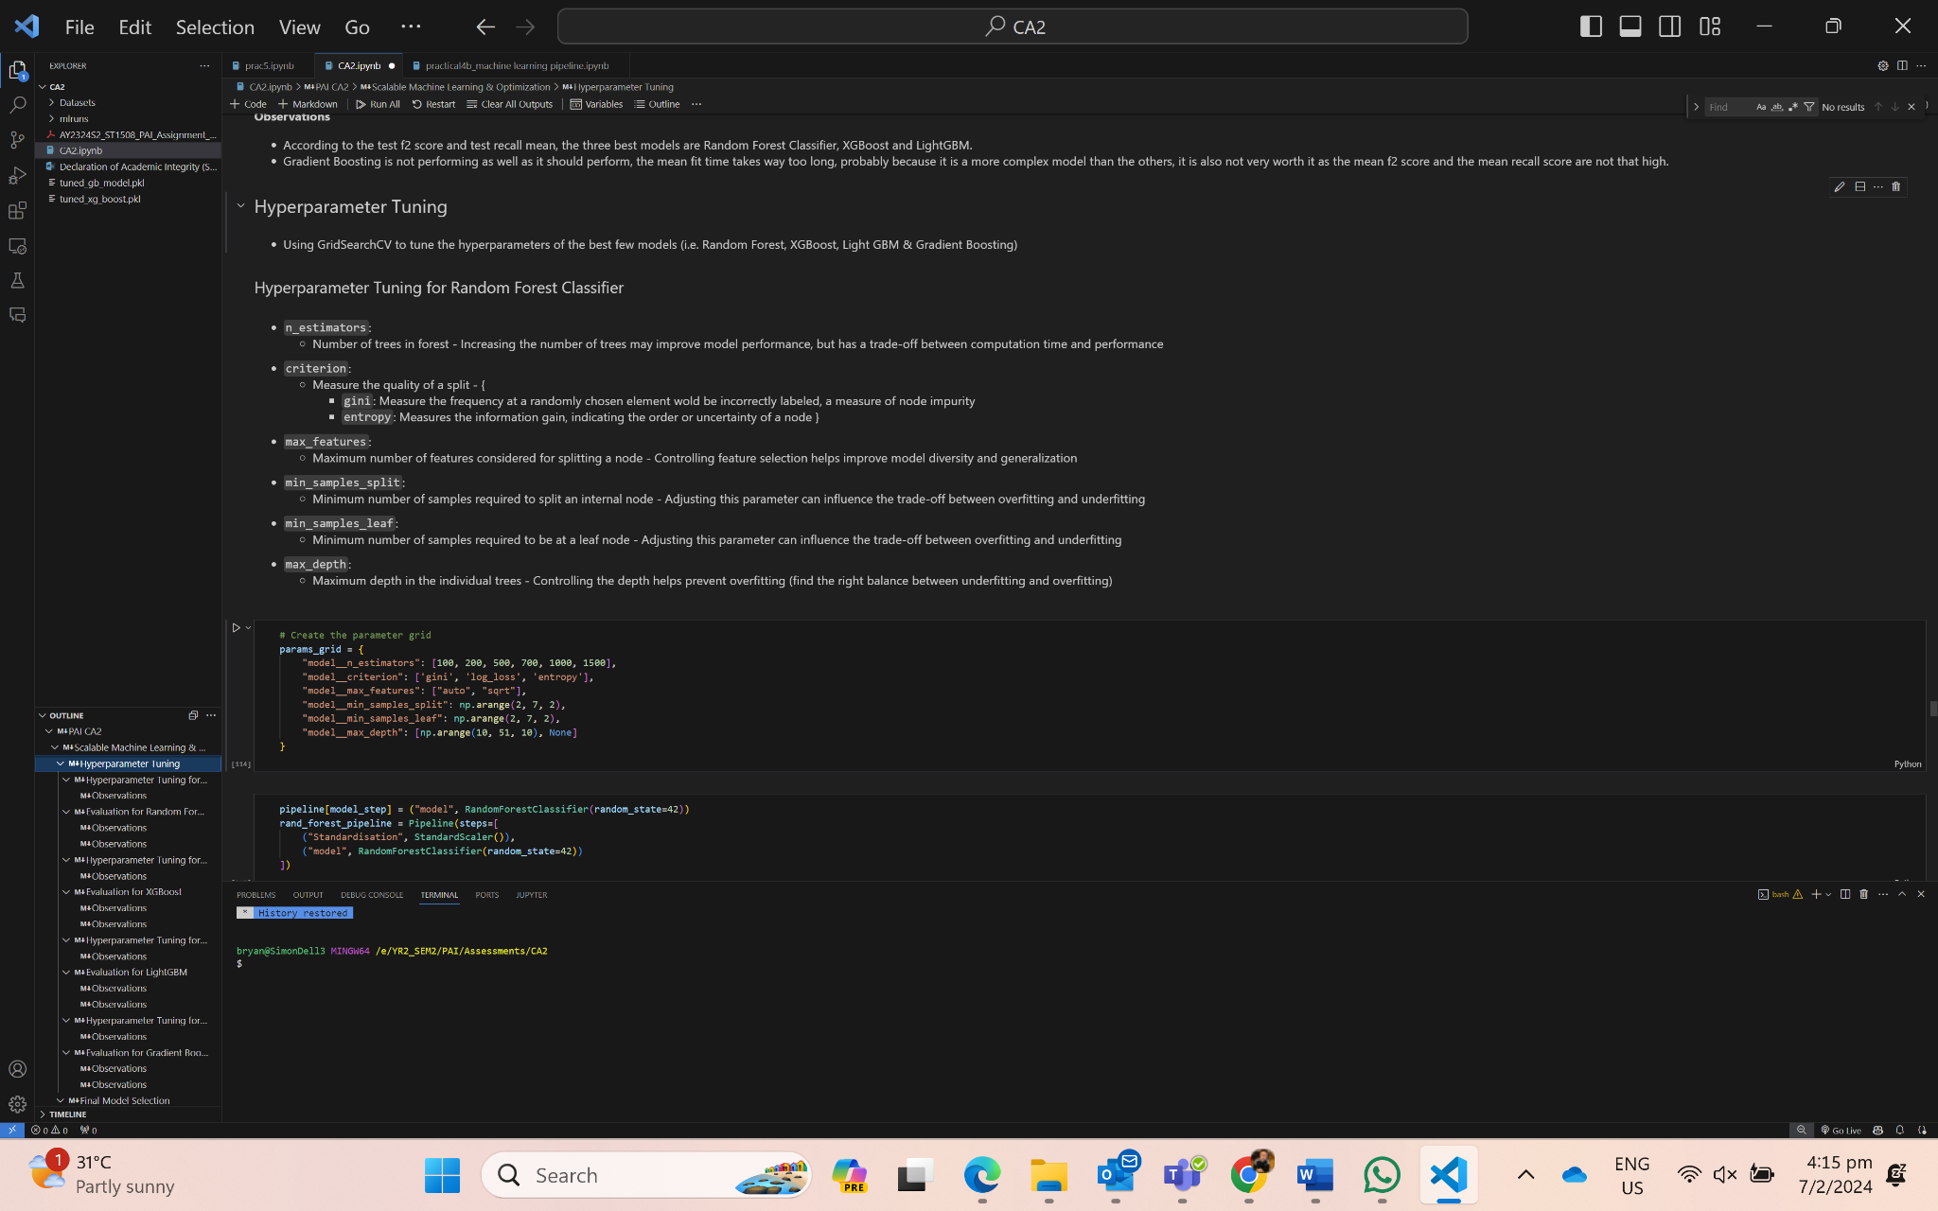

Parameter Grid Optimal Parameters for Best f2 score

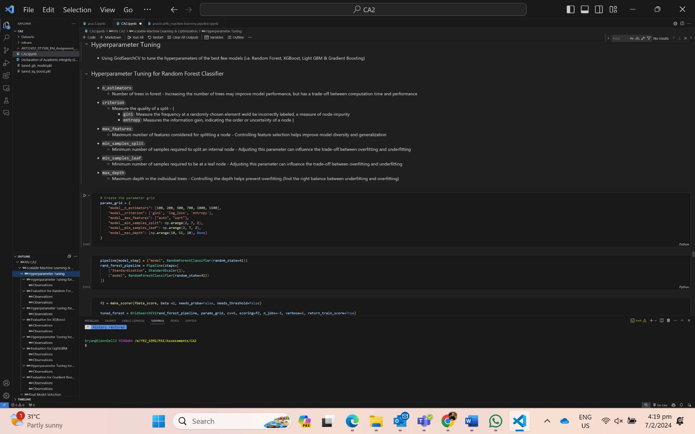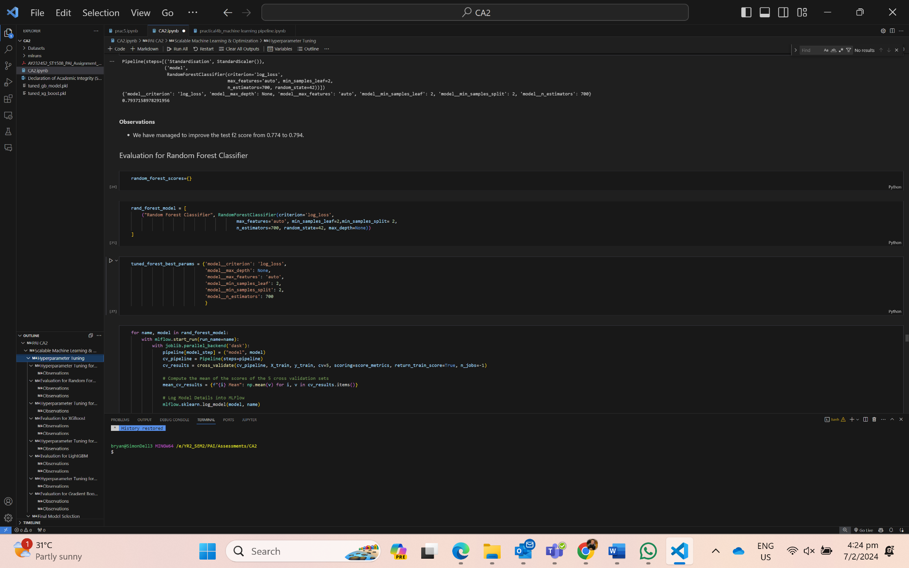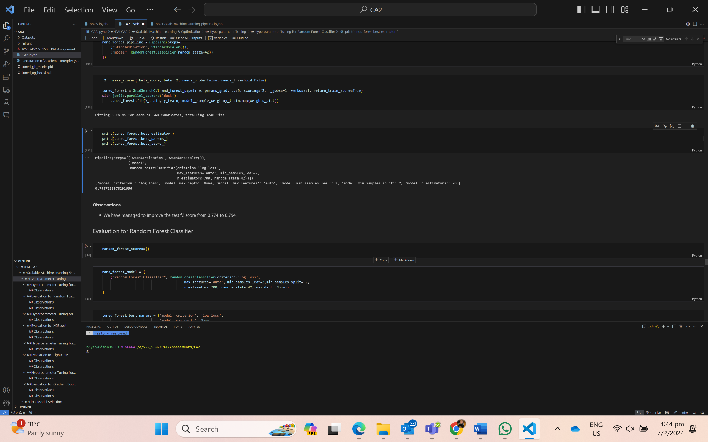

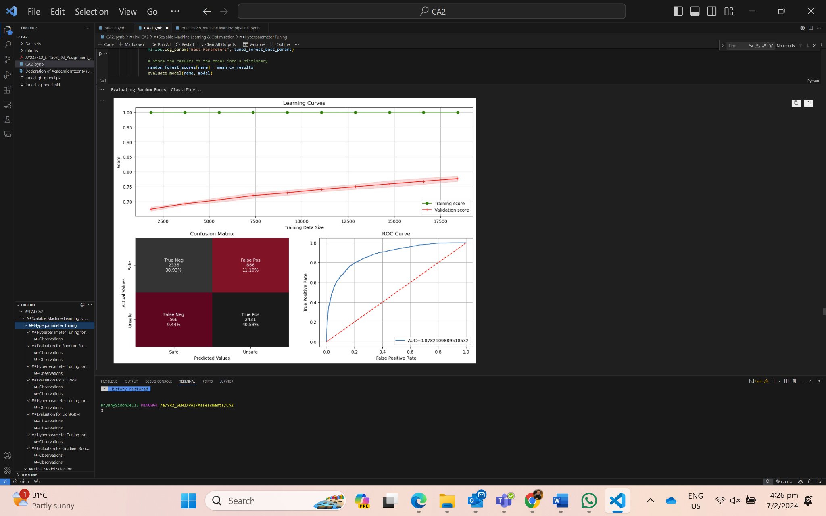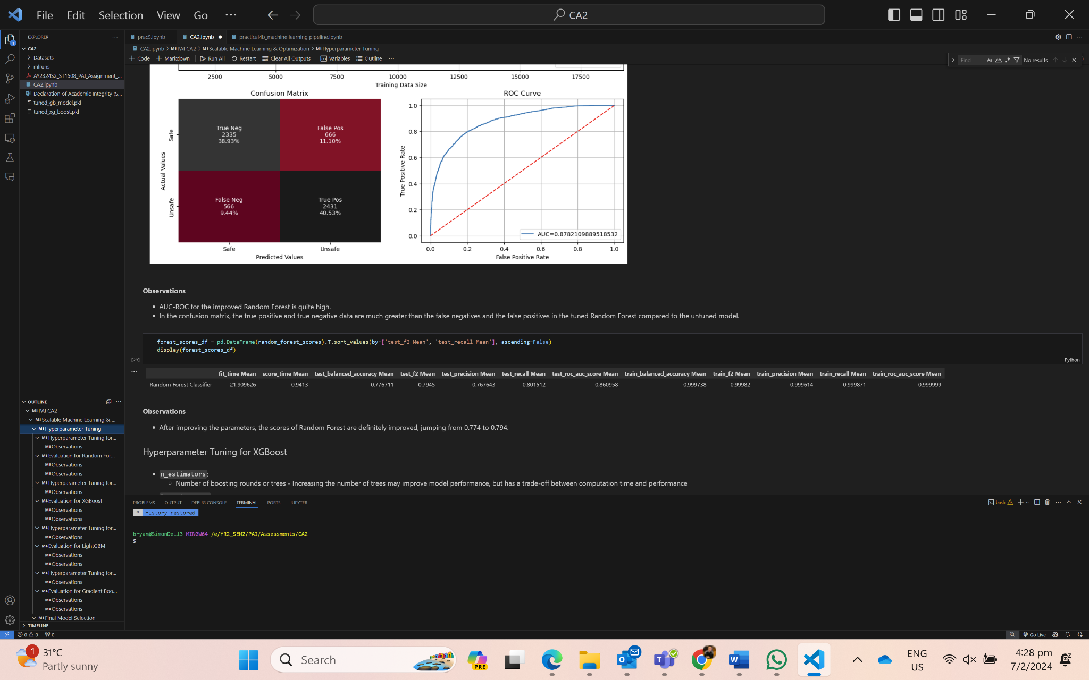

**Observations:**

- The learning curve of the training curve is quite high, implying that the model might have a few signs of overfitting as the model is generalized.

- In the confusion matrix, the true positive and true negative data are much greater than the false negatives and the false positives in the tuned Random Forest compared to the untuned model.

- The scores of Random Forest definitely improved, jumping from 0.774 to 0.794 for f2 score after running the model runs the optimal parameters.

- ROC AUC for this model is quite high which means that the model is quite strong at discriminating between positive and negative instances.

Hyperparameter Tuning - XGBoost

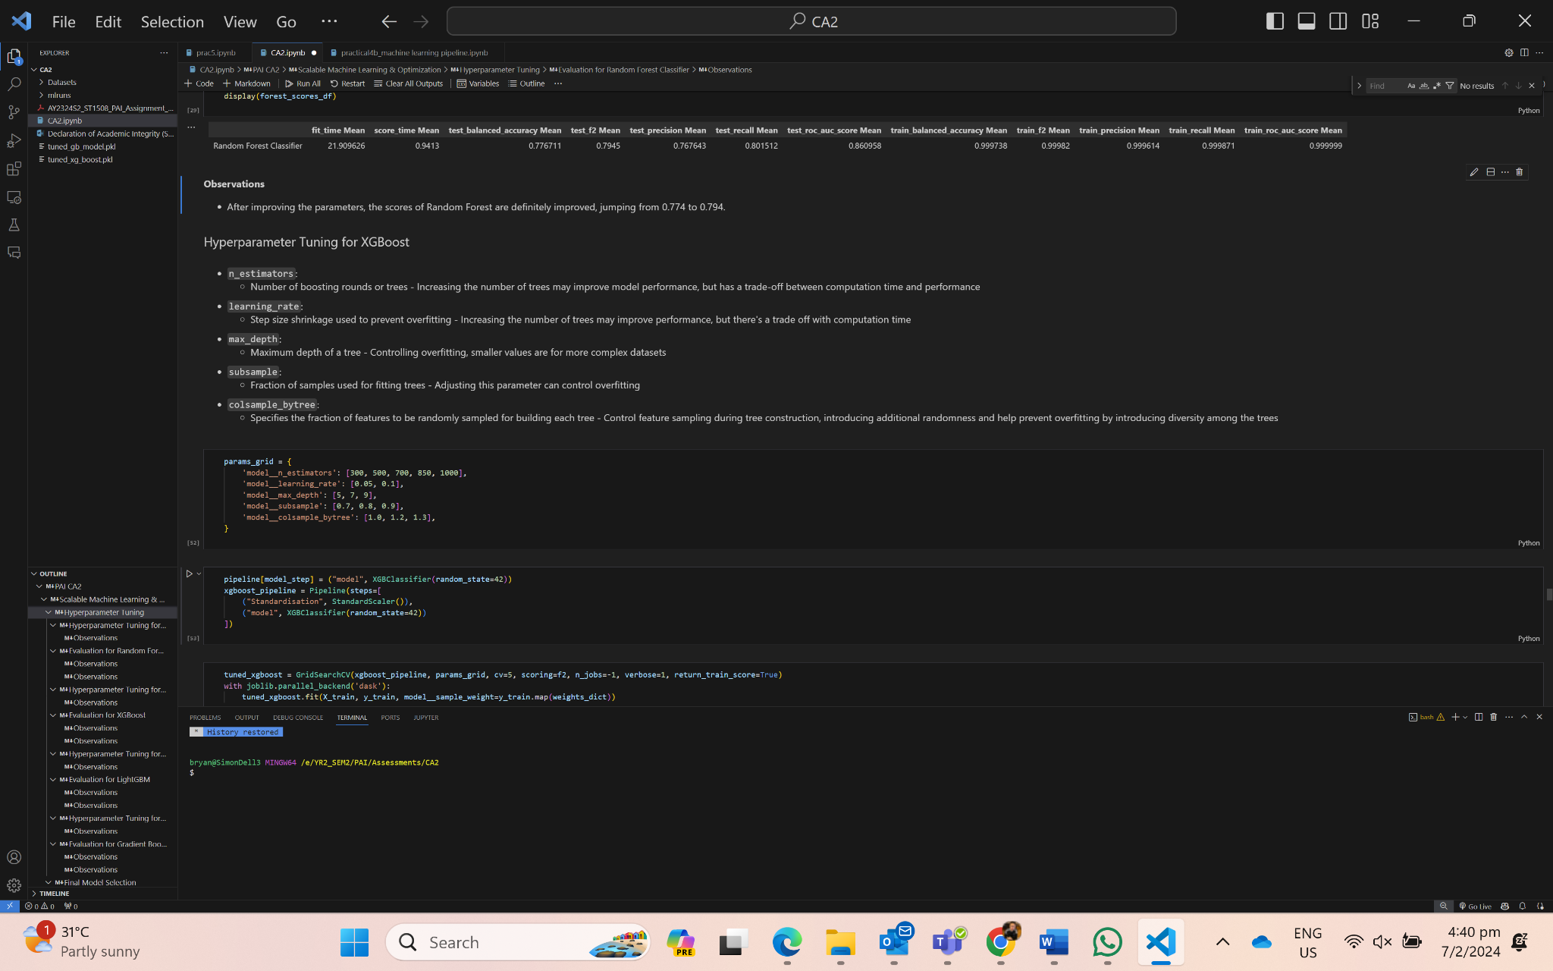

Parameter Grid Optimal Parameters for Best f2 score

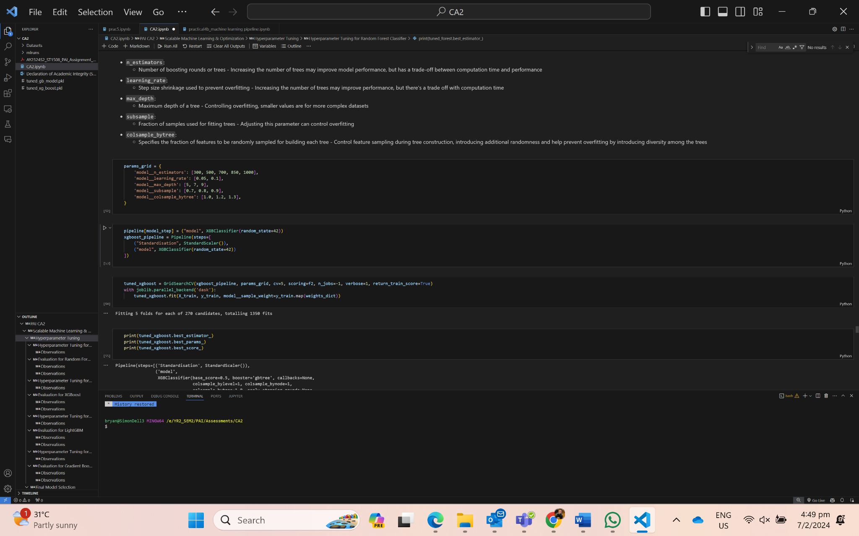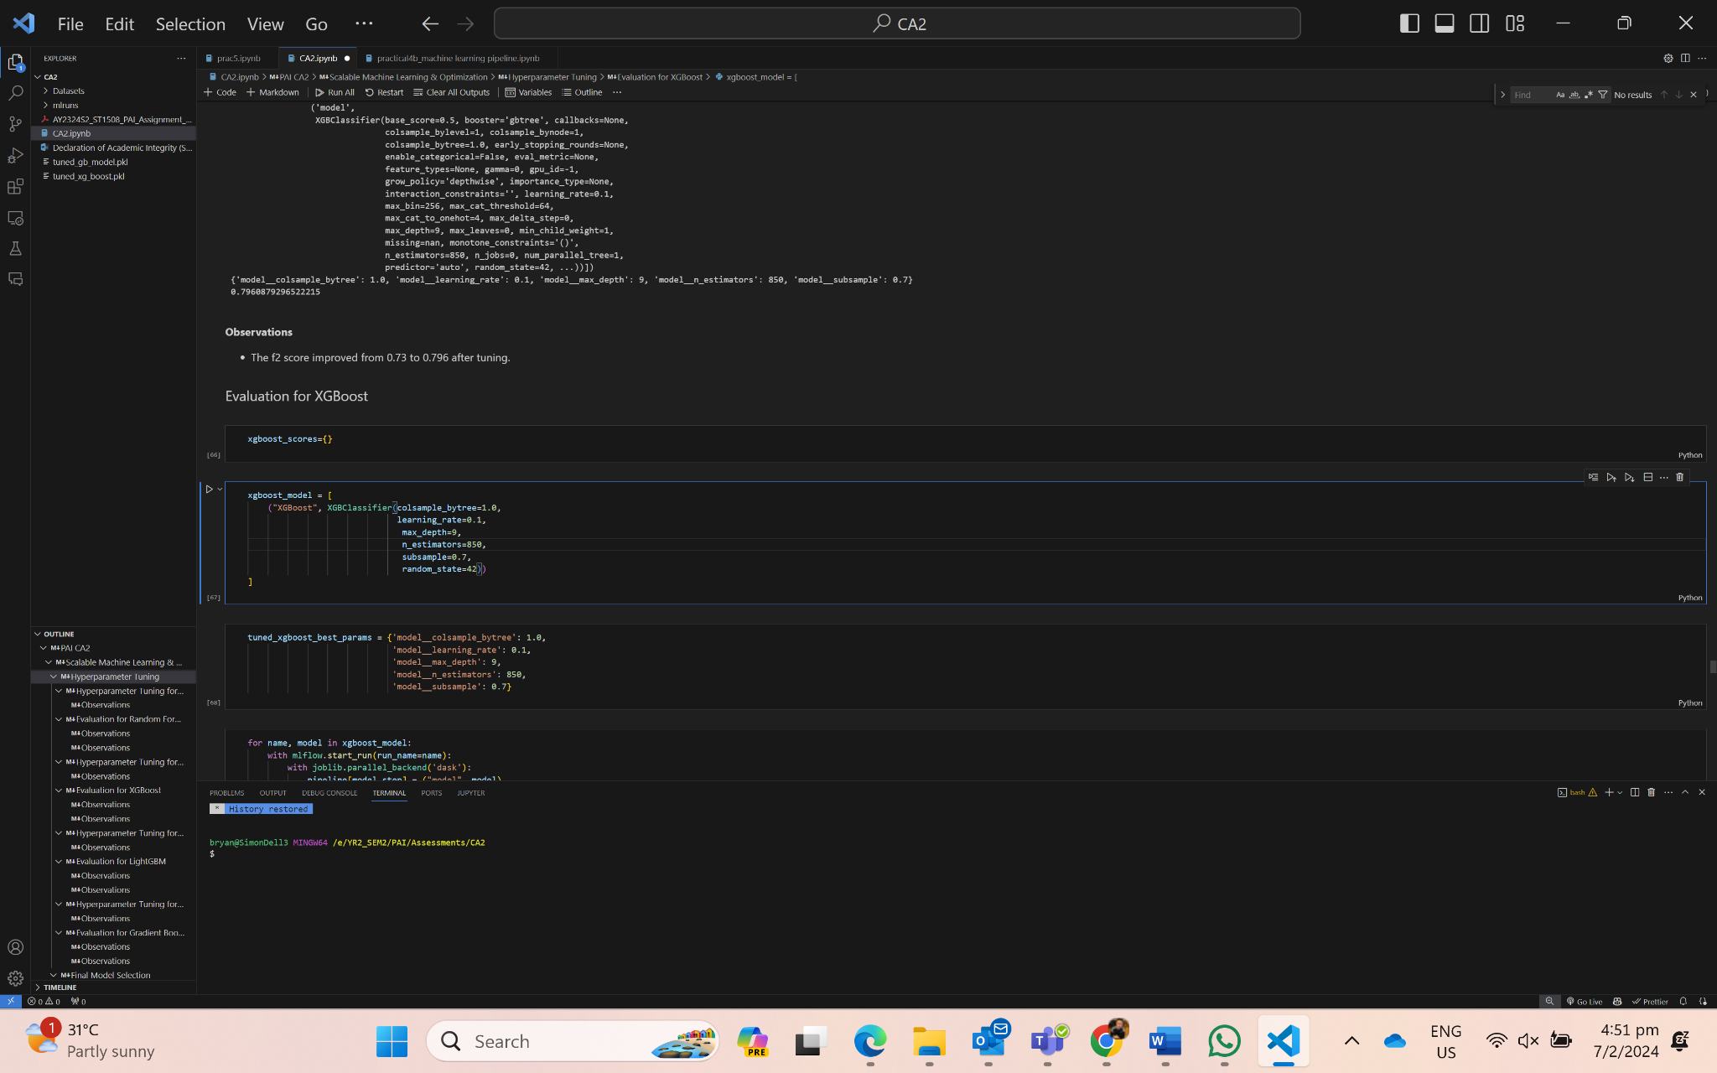



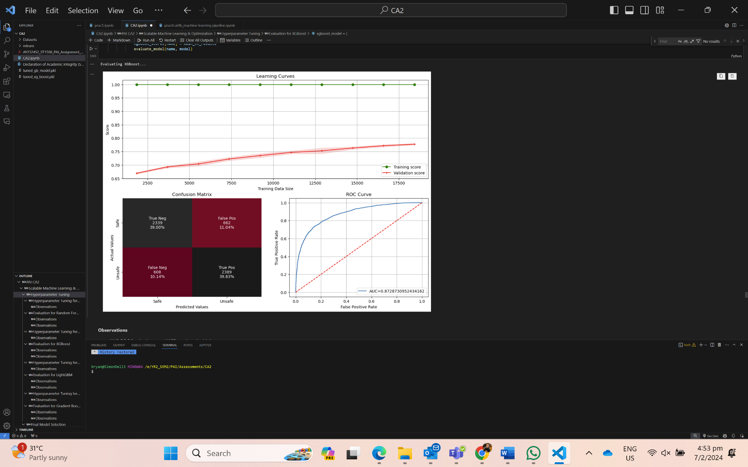

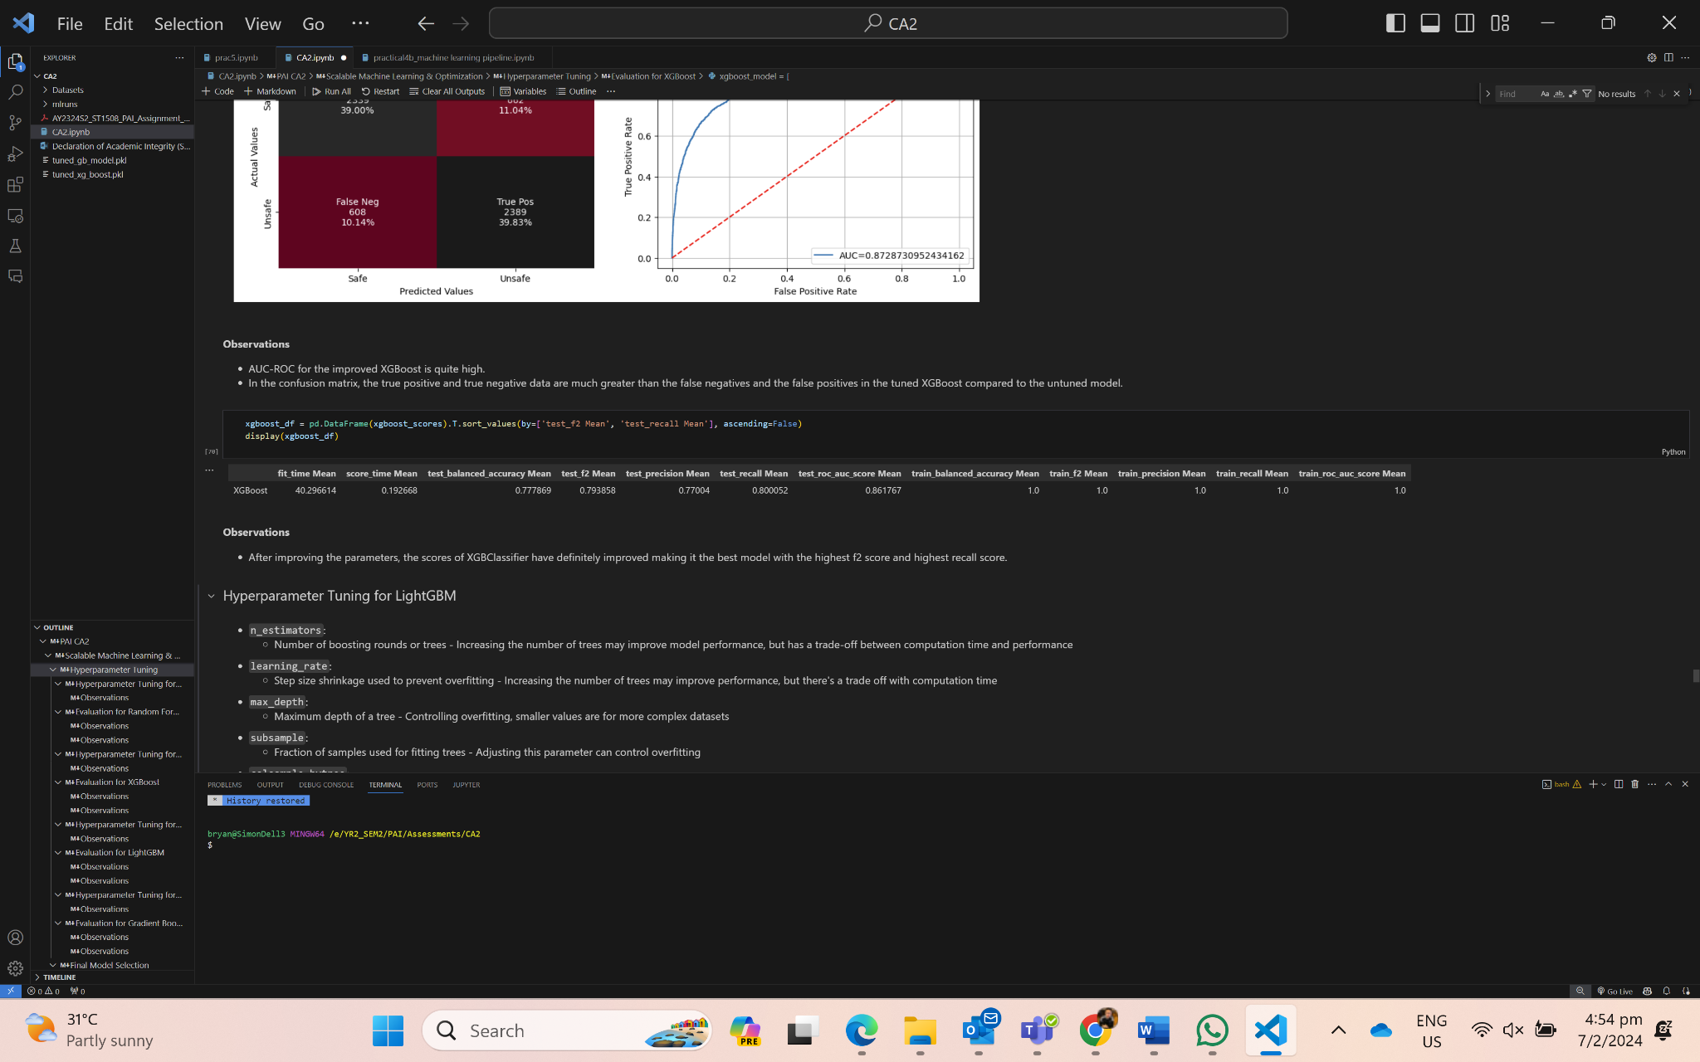

**Observations:**

- The learning curve of the training curve is quite high, implying that the model might have a few signs of overfitting as the model is generalized.

- In the confusion matrix, the true positive and true negative data are much greater than the false negatives and the false positives in the tuned XGBClassifier compared to the untuned model.

- After improving the parameters, the scores of XGBClassifier have definitely improved making it the best model, improving f2 score by 0.01 and recall by 0.07.

- ROC AUC for this model is quite high which means that the model is quite strong at discriminating between positive and negative instances.

Hyperparameter Tuning - GradientBoosting

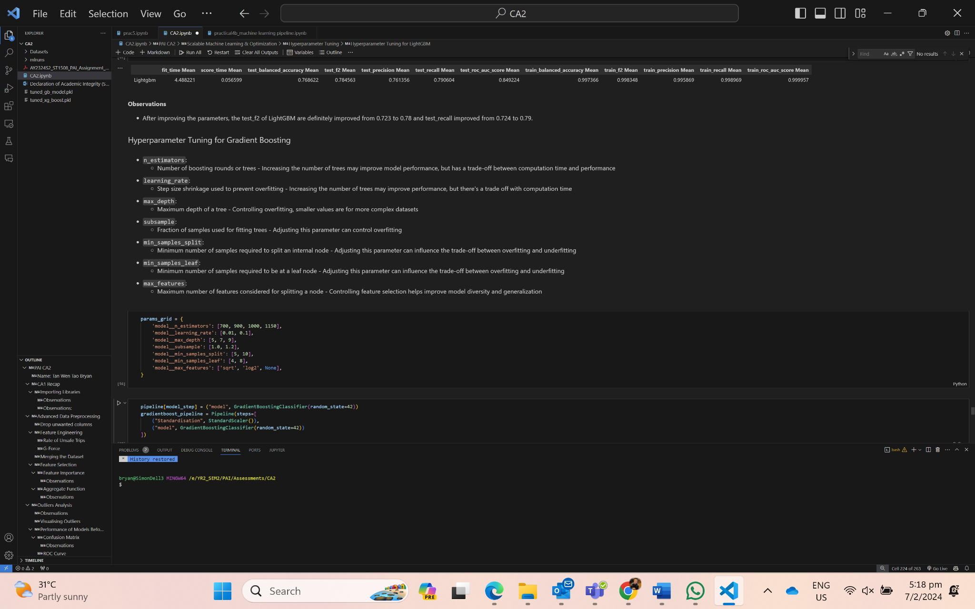

Parameter Grid Optimal Parameters for Best f2 score

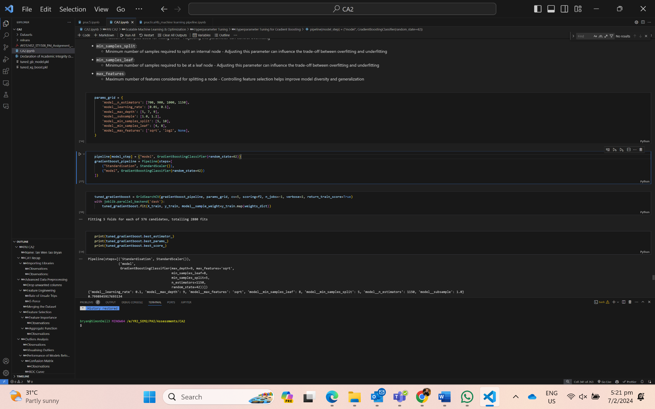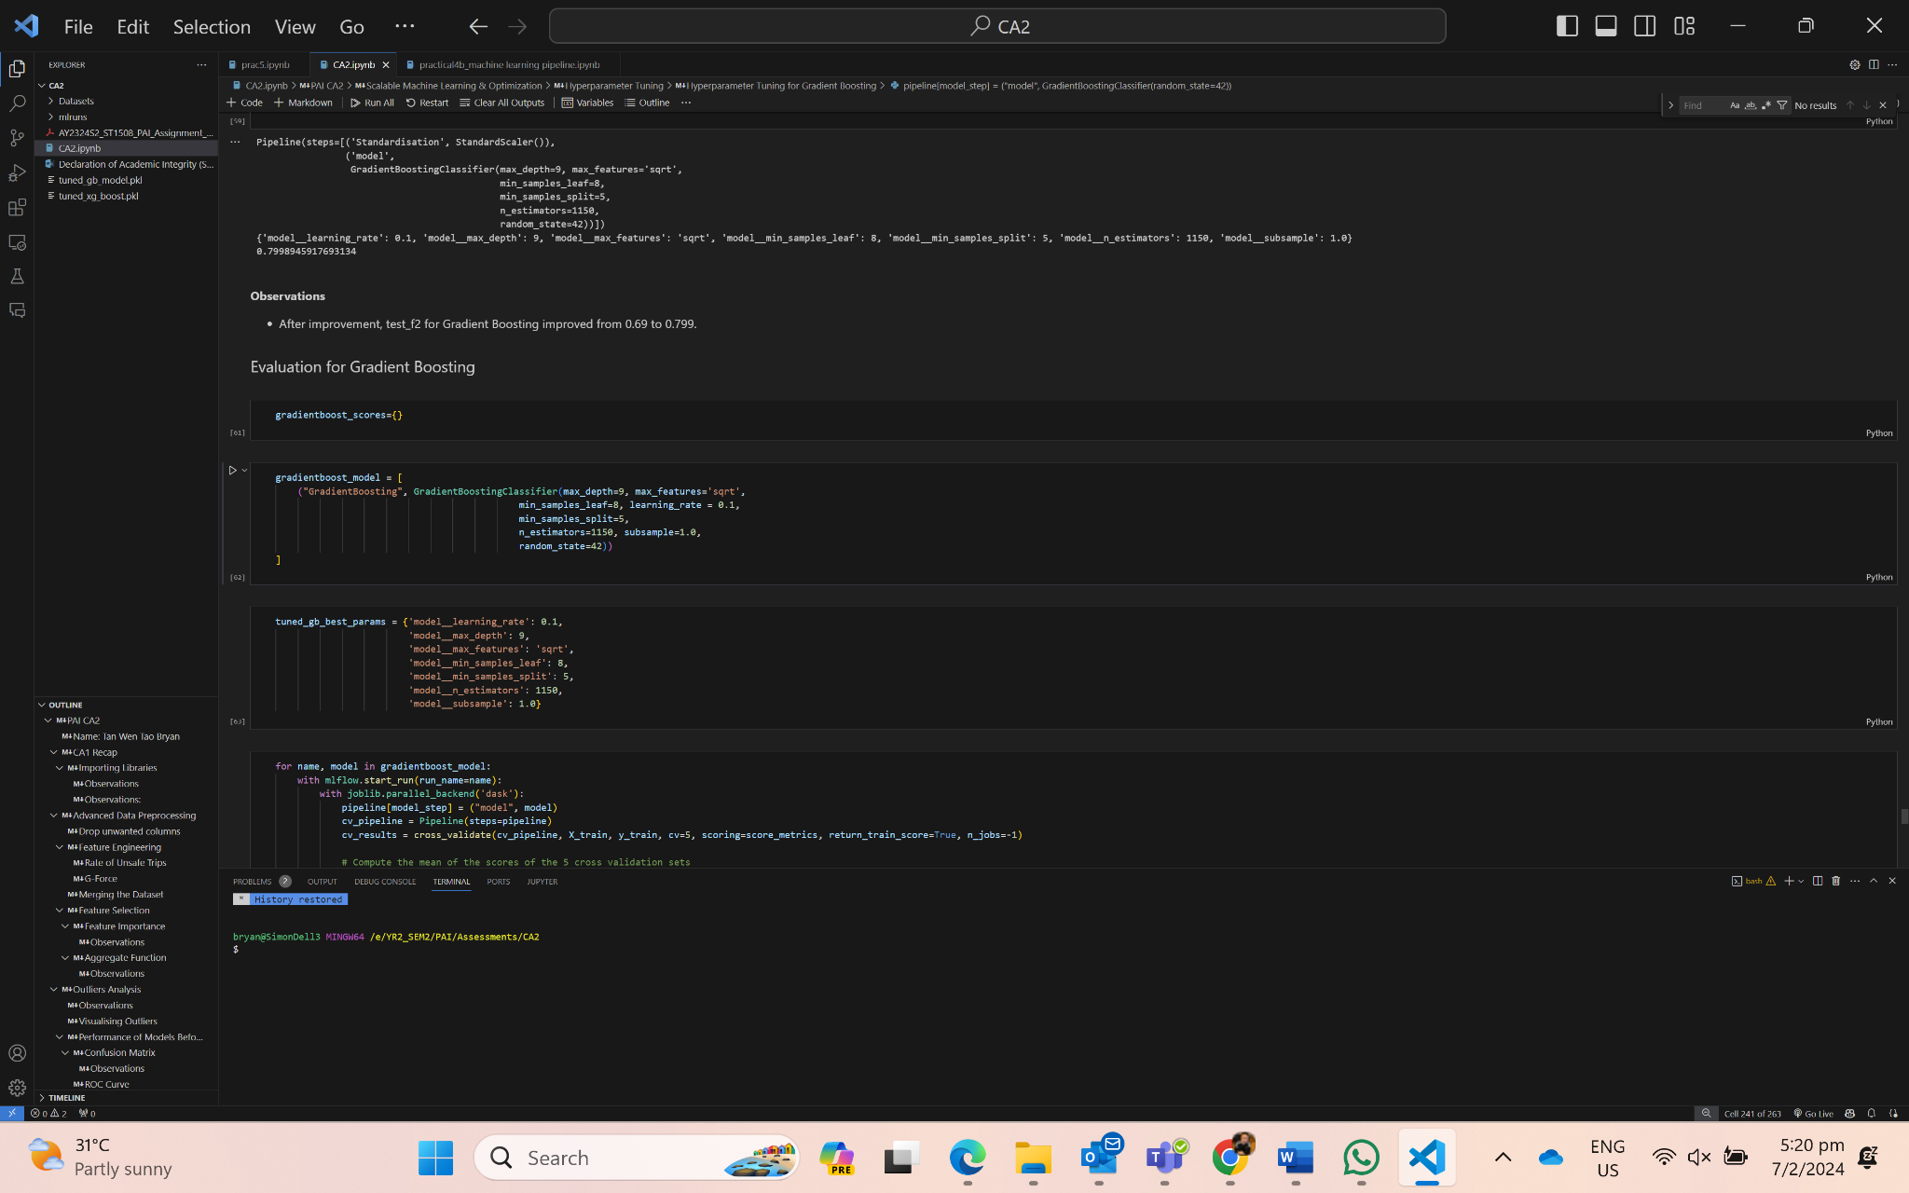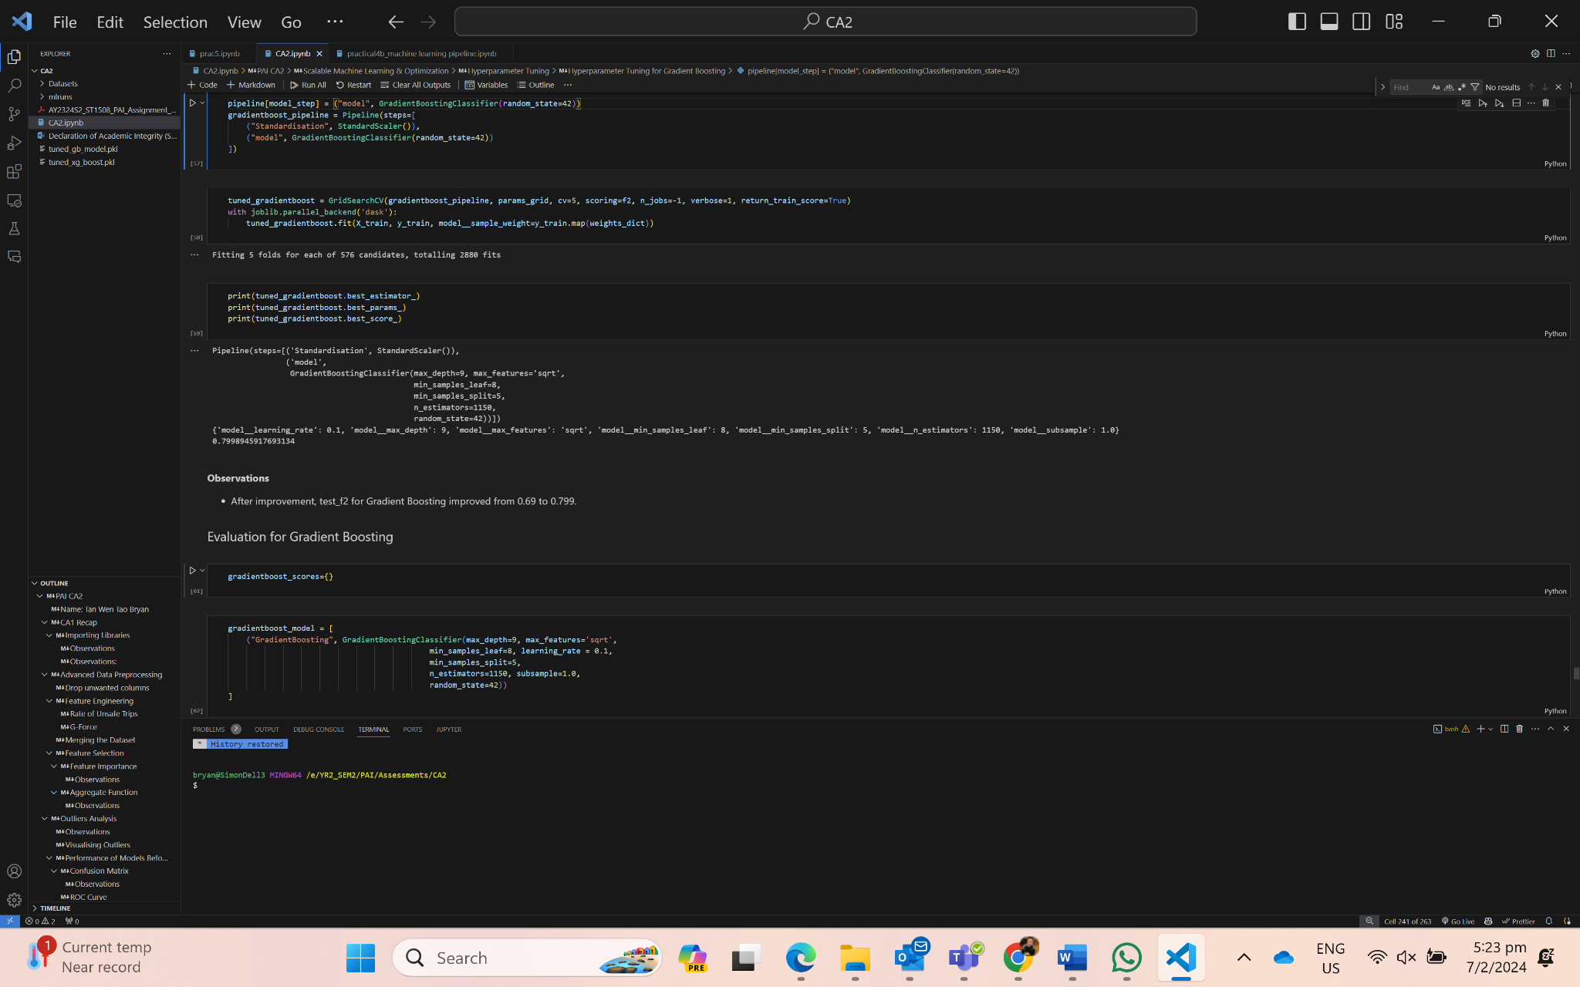

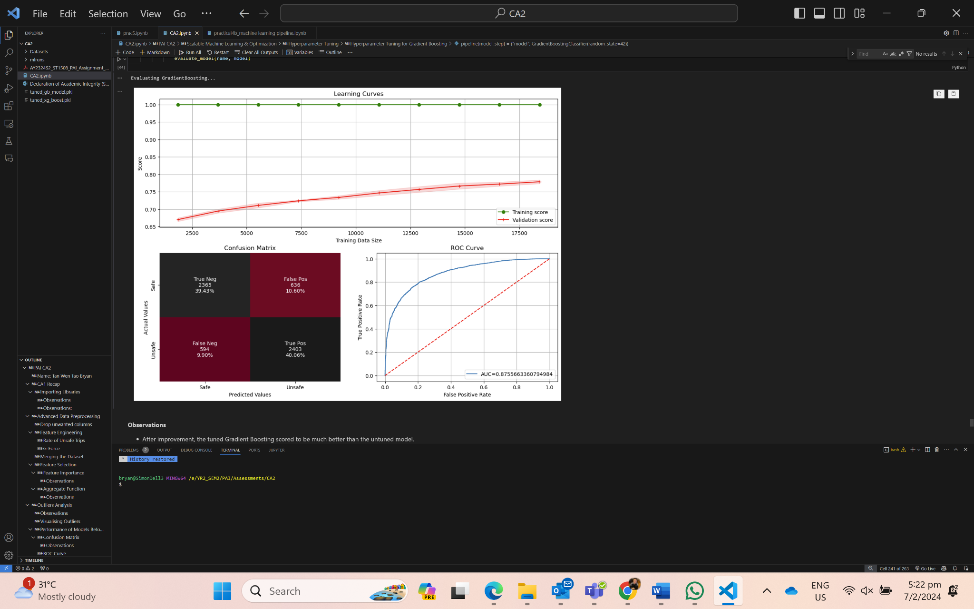

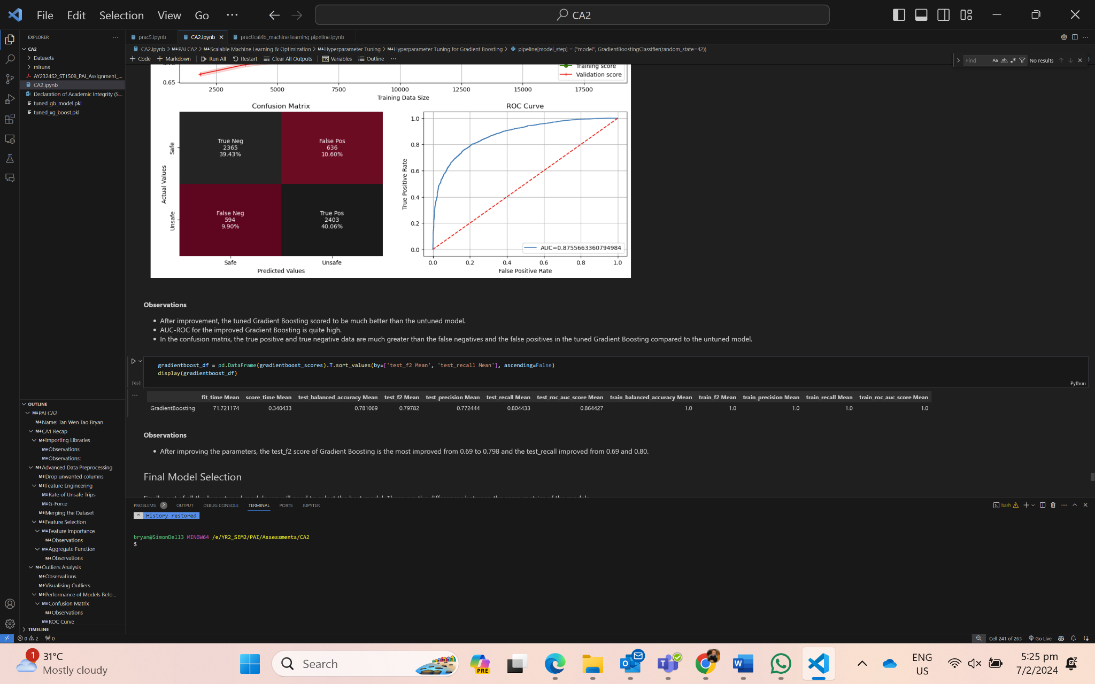

**Observations:**

- The learning curve of the training curve is quite high, implying that the model might have a few signs of overfitting as the model is generalized.

- In the confusion matrix, the true positive and true negative data are much greater than the false negatives and the false positives in the tuned Gradient Boosting compared to the untuned model.

- After improvement, test f2 score for Gradient Boosting improved from 0.69 to 0.799.

- ROC AUC for this model is quite high which means that the model is quite strong at discriminating between positive and negative instances.

- After all, Gradient Boosting is the best model that provides the best f2 score, recall score and even precision score.

4.3 Final Model Export

Since Gradient Boosting was the best performing model, we exported the pipeline for processing data and fitting it into the Gradient Boosting Model as a pickle file so that it can be deployed later on for the GUI development.

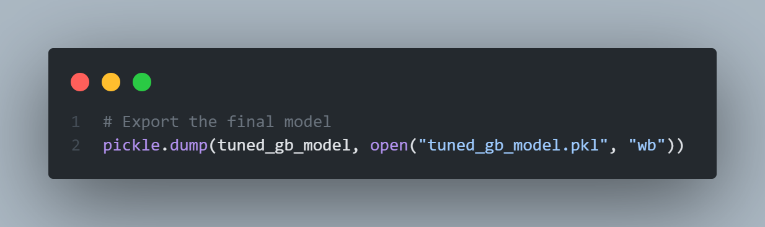

To ensure we saved the model correctly, we reloaded the pickle file and used it to predict data from the test subset.

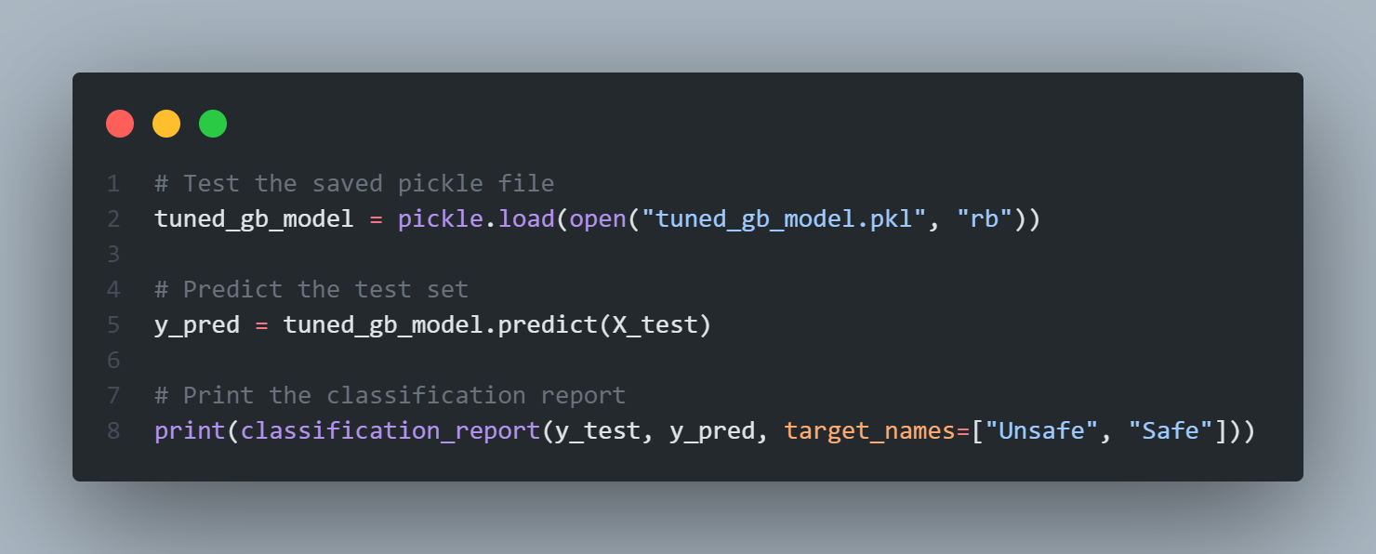

It was able to achieve a high accuracy of 0.79 as shown below:

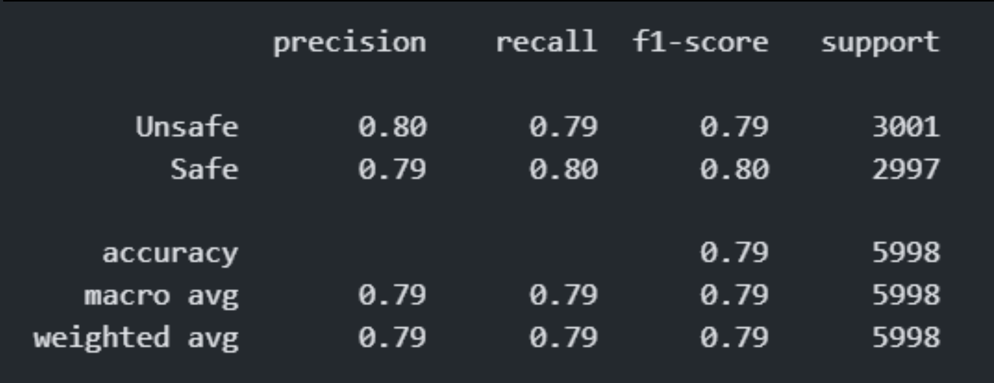

**5 MACHINE LEARNING EXPERIMENT MONITORING**

5.1 MLFlow

MLFlow is an open source platform that allows us to track and compare multiple model runs along with the metrics, allowing us to determine the best model based on the metrics. After each model is trained, the model will be recorded and tracked as a run, where the model parameters and scores will be stored, creating visualizations for comparison. This monitoring process will be integral to refining our models.

We shall monitor these few metrics: Fit time (i.e. Time taken for models to train), Score time (i.e. Time taken for models to score), test_f2 (i.e. More emphasis on correctly identifying dangerous trips while still considering false positive and false negative), test_recall (i.e. Model ability to correctly identify all instances of dangerous trips, minimizing the instances of false negative)

Below shows the scores of all the models before hyperparameter tuning.

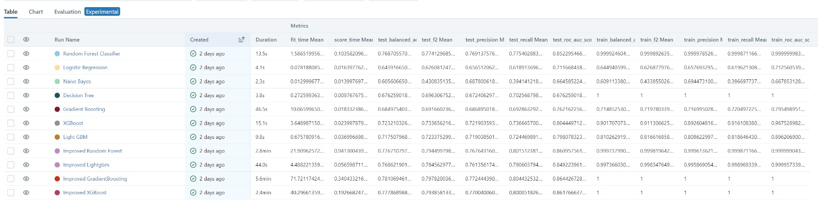

**Observations:**

- Gradient Boosting has the longest fit time, which means it takes a while to train but has quite a short score time which means it is quite fast at predicting.

- Random Forest has the best test_f2 score and test_recall, but has a much longer fit time due to it being a more complex model.

- LightGBM and XGBoost are also two models, other than Gradient Boosting, with the highest f2 score and recall score, along with the shortest score time compared to other models.

Below shows the scores between the untuned and tuned models.

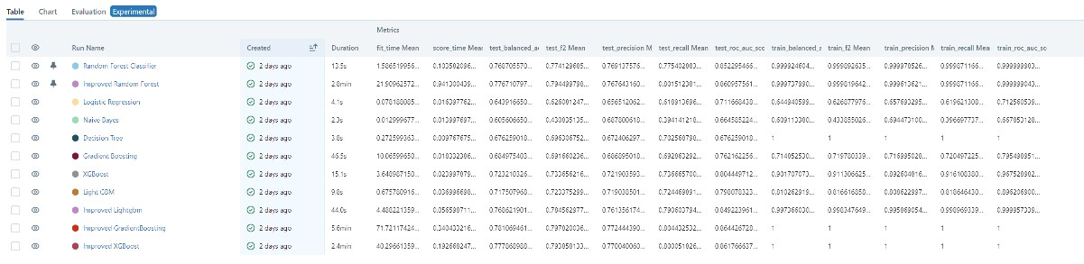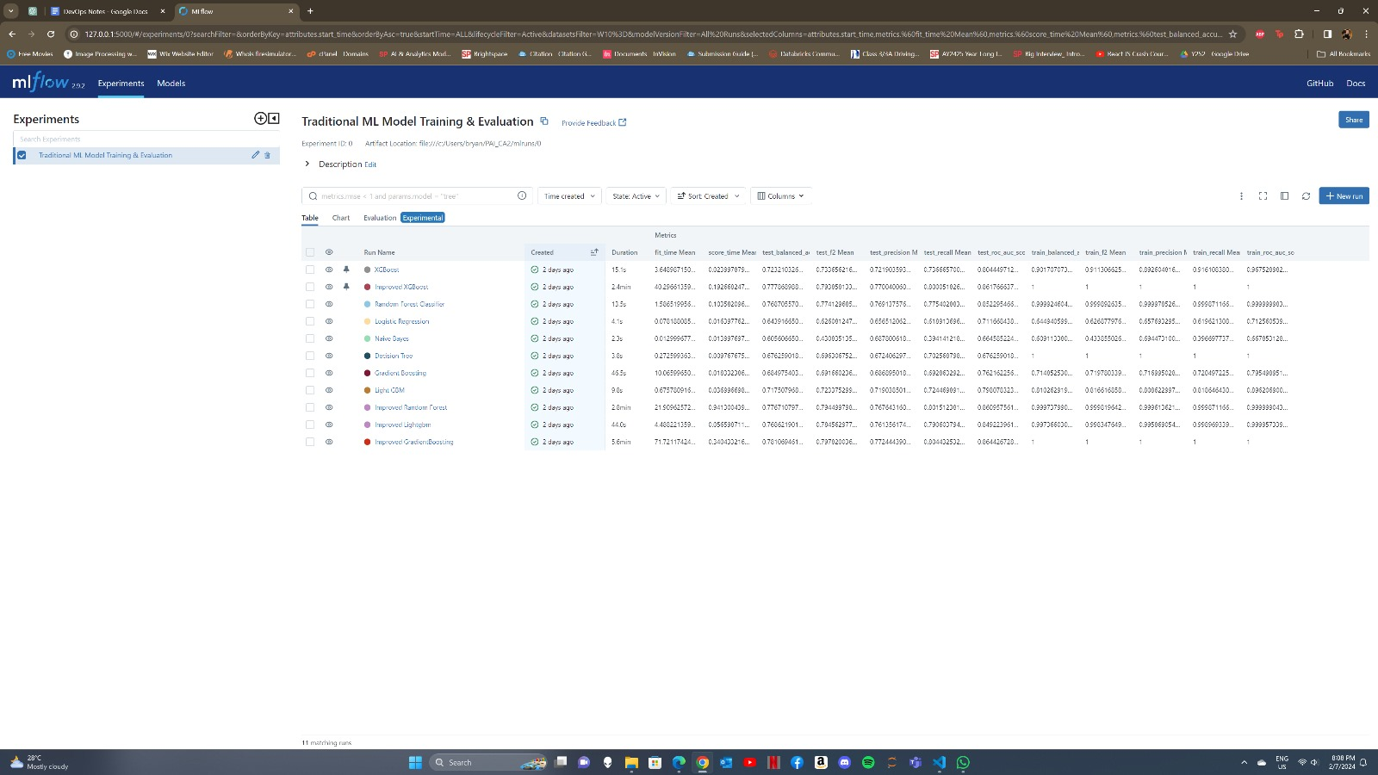

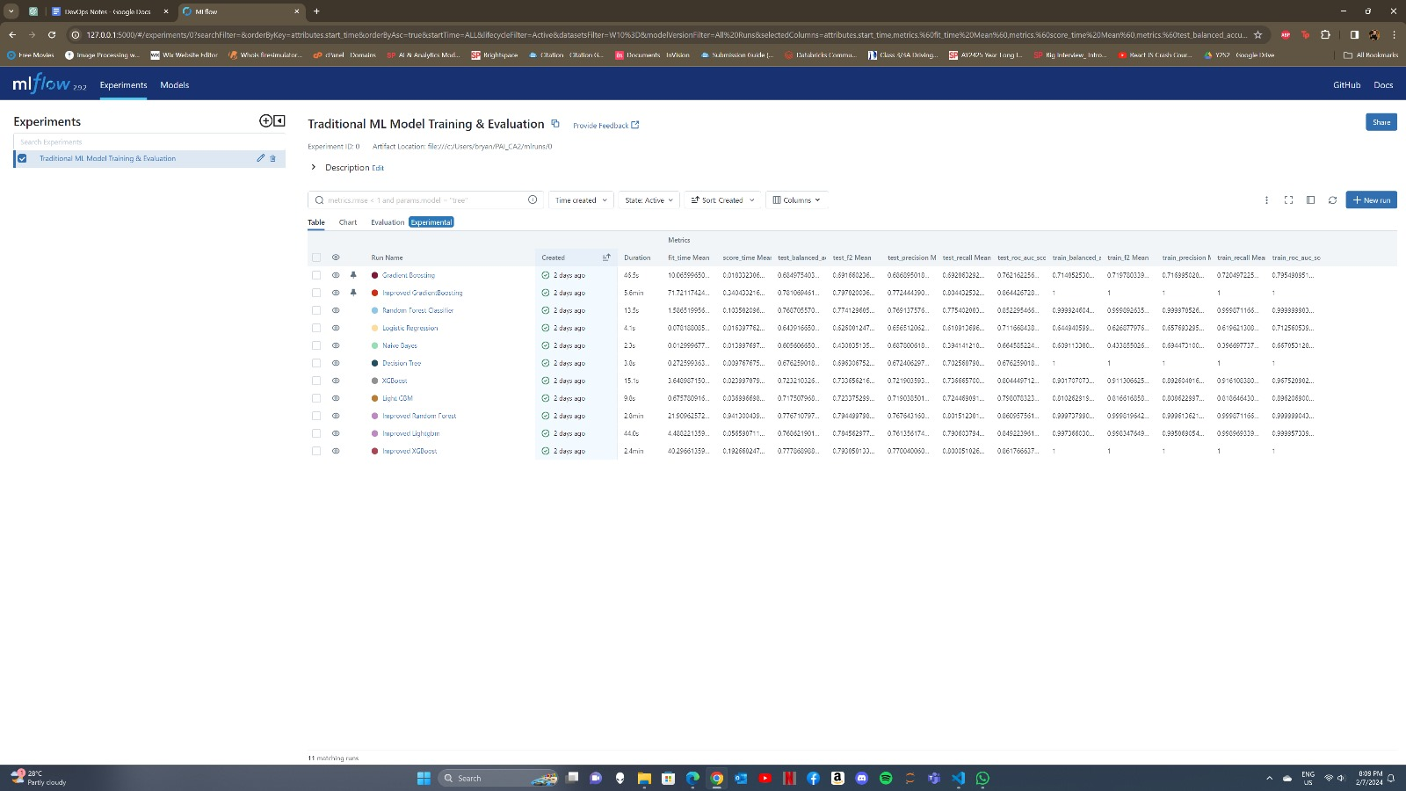

Just comparing the tuned and untuned models, all the score metrics show an improvement in the tuned models from the untuned models.

Below shows the mean fit time and mean score time of all the models.

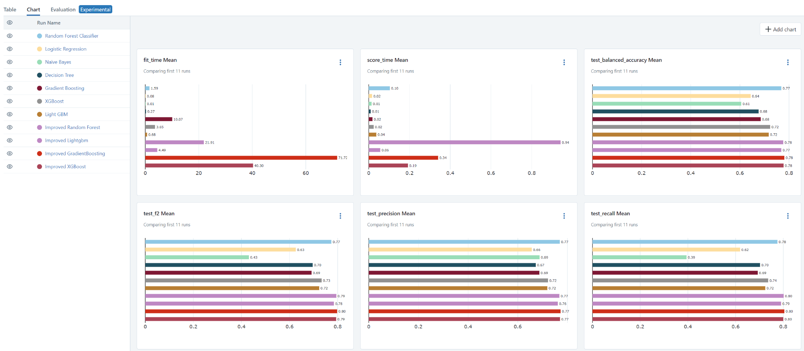

As such, improved gradient boosting has the highest fit time but a much relatively lower score time in general. However, the improved random forest has a much higher score time than most models, which is why we will not be using RandomForest as the deployed model.

Out of all the hypertuned models, we will need to select the best model. These are the differences between the score metrics of the best 4 models.

1. Mean_fit_time - For mean fit time, RandomForestClassifier took 21.9, XGBoost took 33.6, LightGBM took 4.49, GradientBoosting took 65.0. This implies that LightGBM is the most lightweight model with the fastest training time, followed by XGBoost, RandomForest and GradientBoosting is the most heavyweight model with the longest training time.

2. Mean_score_time - For mean score time, RandomForestClassifier took 0.941, XGBoost took 0.161, LightGBM took 0.057, GradientBoosting took 0.271. This implies that LightGBM is the most lightweight model with the fastest scoring time, followed by XGBoost, GradientBoosting and Random Forest is the most heavyweight model with the longest scoring time.

3. Mean_test_f2 - For mean test f2 score, RandomForestClassifier took 0.794, XGBoost took 0.791, LightGBM took 0.785, GradientBoosting took 0.796. This implies that GradientBoosting is the most robust model to predict if a trip was safe or dangerous, followed by RandomForestClassifier, XGBoost and LightGBM.

4. Mean test_recall - For mean test recall score, RandomForestClassifier took 0.801, XGBoost took 0.798, LightGBM took 0.791, GradientBoosting took 0.803. This implies that GradientBoosting is the best model to correctly identify most of the dangerous trips, minimizing the risk of overlooking safety concerns.

In summary, we will be deploying Gradient Boosting as our final model for our Graphical User Interface.

**6 MODEL DEPLOYMENT**

6.1 Tkinter Graphical User Interface

Tkinter is a module used in Python for building Graphical User Interface (GUI), allowing us to use our model for predictions in external environments outside of a Jupyter Notebook. To do this, we first had to load the pipeline containing our model from the previously saved Pickle file for prediction later on.

Outside of its main feature of being able to predict the safety of trips, the GUI boasts several other features such as:

* Light Mode/Dark Mode switch for aesthetic effect
* Batch insert of multiple trips as CSV or XLSX
* Export the results as CSV
* Displays the probability of how safe or unsafe the trip may be
* Change model according to preference

Below, the application is used to predict from a row already present in the dataset with the label ‘0’. After keying in the parameters, the model is quite confident (91.60%) that the prediction is safe, matching the dataset.

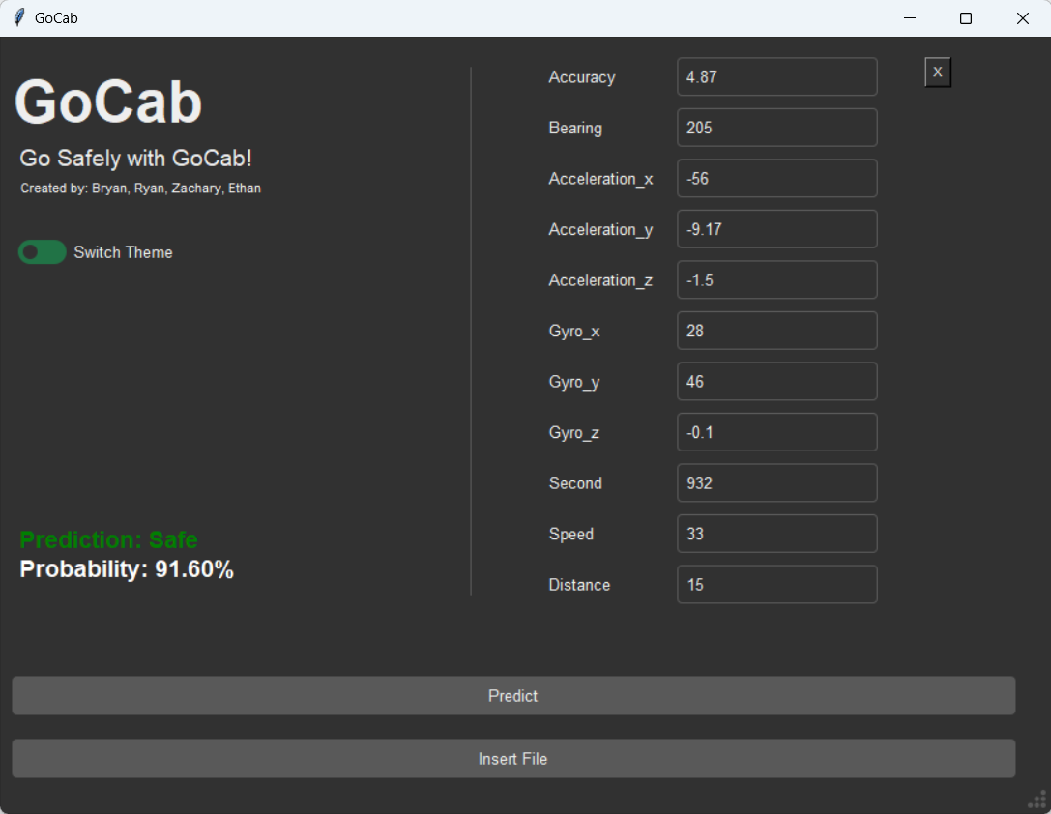

After increasing the acceleration and speed to a much higher value, the model now predicts that the trip is ‘Unsafe’ and is a lot more confident in the trip being unsafe as well (99.33%)

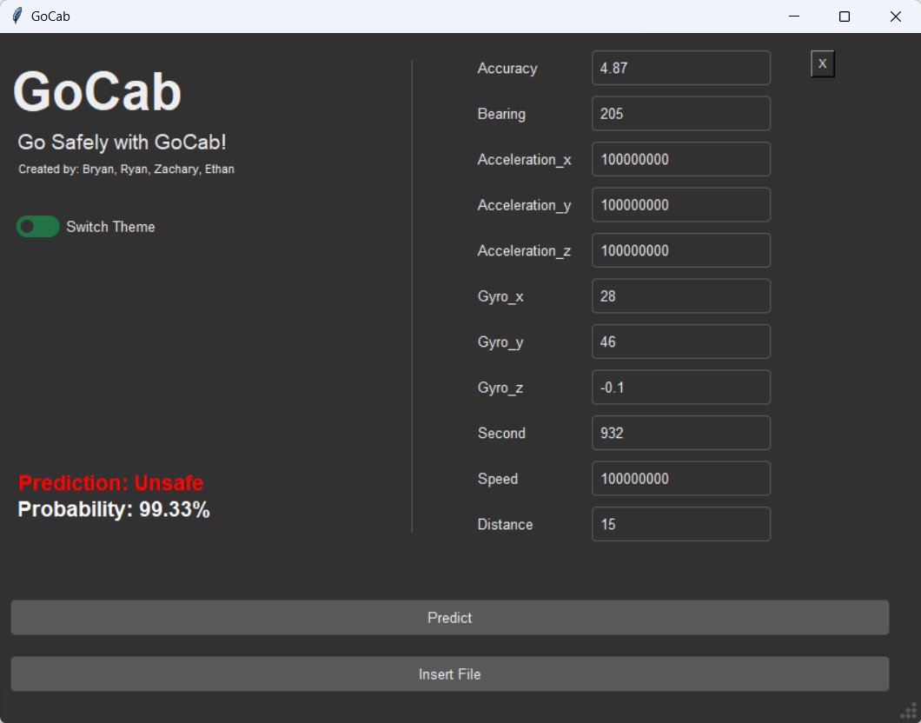

**7 CONCLUSION**

In conclusion, the GoBest Cab Data Science Team has successfully navigated through the second phase of the project. Throughout the second phase of the project, the team has managed to perform advanced data preprocessing like handling outliers in high dimensional data, build, optimize and scale machine learning models, use MLFlow to track and monitor the model experiments and performance, and lastly, deploy the model in the form of a GUI using Tkinter. As such, the team has successfully developed an easy to use, and intuitive machine learning software application that can help the administrators and managers to identify safe and dangerous trips, allowing them to come up with precautions to minimize the occurrences of dangerous trips, greatly reducing the probability of accidents to happen and possibly saving many cab drivers lives.